Elizabeth Warren’s speech to the AFL-CIO
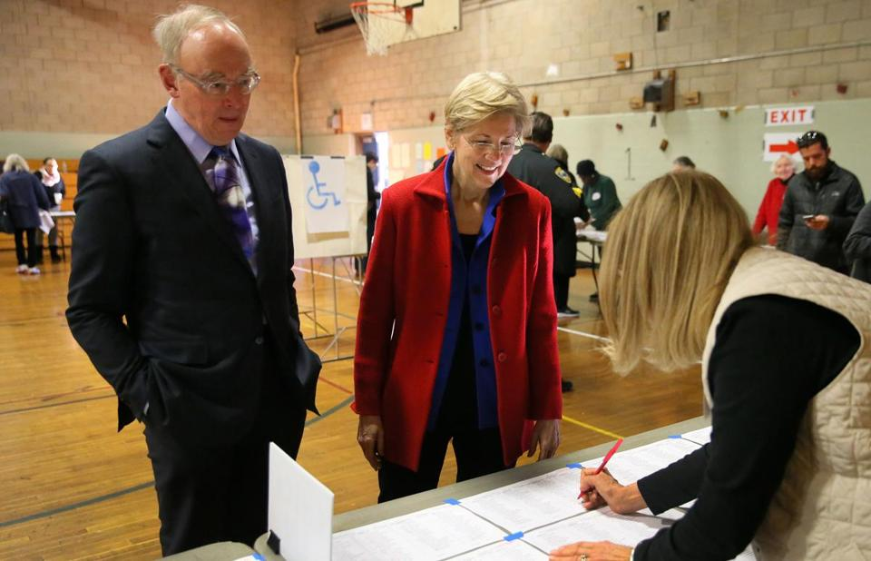
Elizabeth Warren and her husband, Bruce Mann, checked in to vote in Cambridge on Tuesday. Photo: David L. Ryan/Globe Staff.
Below are the prepared remarks by Senator Elizabeth Warren to the AFL-CIO Executive Council Thursday in Washington, D.C. November 10, 2016
We’re now two days removed from an incredibly close and hard-fought election, and many people here in Washington and around the country are trying to make sense of what happened.
This wasn’t a pretty election. In fact, it was ugly, and we should not sugarcoat the reason why. Donald Trump ran a campaign that started with racial attacks and then rode the escalator down. He encouraged a toxic stew of hatred and fear. He attacked millions of Americans. And he regularly made statements that undermined core values of our democracy.
And he won. He won - and now Latino and Muslim-American children are worried about what will happen to their families. LGBT couples are worried that their marriages could be dissolved by a Trump-Pence Supreme Court. Women are worried that their access to desperately needed health services will disappear. Millions of people in this country are worried, deeply worried. And they are right to be worried.
Today, as President-Elect, Donald Trump has an opportunity to chart a different course: to govern for all Americans and to respect our institutions. In his victory speech, he pledged that he would be “President for all” of the American people. And when he takes the oath of office as the leader of our democracy and the leader of all Americans, I sincerely hope that he will fulfill that pledge with respect and concern for every single human being in this country, no matter who they are, no matter where they come from, no matter what they believe, no matter whom they love.

And that marks Democrats’ first job in this new era: We will stand up to bigotry. There is no compromise here. In all its forms, we will fight back against attacks on Latinos, African Americans, women, Muslims, immigrants, disabled Americans-on anyone. Whether Donald Trump sits in a glass tower or sits in the White House, we will not give an inch on this, not now, not ever.
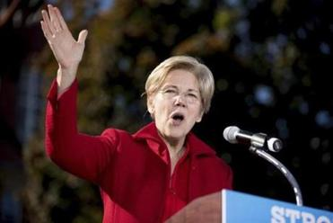
But there are many millions of people who did not vote for Donald Trump because of the bigotry and hate that fueled his campaign rallies. They voted for him despite the hate. They voted for him out of frustration and anger-and also out of hope that he would bring change.
If we have learned nothing else from the past two years of electioneering, we should hear the message loud and clear that the American people want Washington to change. It was clear in the Democratic Primaries. It was clear in the Republican Primaries. It was clear in the campaign and it was clear on Election Day. The final results may have divided us - but the entire electorate embraced deep, fundamental reform of our economic system and our political system.
Working families across this country are deeply frustrated about an economy and a government that doesn’t work for them. Exit polling on Tuesday found that 72 percent of voters believe that, quote, “the American economy is rigged to advantage the rich and powerful.” 72 percent of ALL voters-Democrats and Republicans.1 The polls were also made clear that the economy was the top issue on voters’ minds. Americans are angry about a federal government that works for the rich and powerful and that leaves everyone else in the dirt.
Lobbyists and Washington insiders have spent years trying to convince themselves and each other that Americans don’t actually believe this. Now that the returns are in and the people have spoken, they’re already trying to wave their hands and dismiss these views as some sort of mass delusion. They are wrong-very wrong.
The truth is that people are right to be angry. Angry that wages have been stagnant for a generation, while basic costs like housing, health care, and child care have skyrocketed. Angry that our political system is awash in barely legalized campaign bribery. Angry that Washington eagerly protects tax breaks for billionaires while it refuses to raise the minimum wage, or help the millions of Americans struggling with student loans, or enforce the law when the millionaire CEOs who fund our political campaigns break it. Angry that Washington pushes big corporate interests in trade deals, but won’t make the investments in infrastructure to create good jobs right here in America. Angry that Washington tilts the playing field for giant corporations - giving them special privileges, letting them amass enormous economic and political power.
Angry that while Washington dithers and spins and does the backstroke in an ocean of money, while the American Dream moves further and further out of reach for too many families. Angry that working people are in debt. Angry that seniors can’t stretch a Social Security check to cover the basics.
President-Elect Trump spoke to these issues. Republican elites hated him for it. But he didn’t care. He criticized Wall Street and big money’s dominance in Washington-straight up. He supported a new Glass-Steagall. He spoke of the need to reform our trade deals so they aren’t raw deals for the American people. He said he will not cut Social Security benefits. He talked about the need to address the rising cost of college and about helping working parents struggling with the high cost of child care. He spoke of the urgency of rebuilding our crumbling infrastructure and putting people back to work. He spoke to the very real sense of millions of Americans that their government and their economy has abandoned them. And he promised to rebuild our economy for working people.
The deep worry that people feel over an America that does not work for them is not liberal or conservative worry. It is not Democratic or Republican worry. It is the deep worry that led even Americans with very deep reservations about Donald Trump’s temperament and fitness to vote for him anyway.
So let me be 100% clear about this. When President-Elect Trump wants to take on these issues, when his goal is to increase the economic security of middle class families, then count me in. I will put aside our differences and I will work with him to accomplish that goal. I offer to work as hard as I can and to pull as many people as I can into this effort. If Trump is ready to go on rebuilding economic security for millions of Americans, so am I and so are a lot of other people-Democrats and Republicans.
But let’s also be clear about what rebuilding our economy does not mean.
It does not mean handing the keys to our economy over to Wall Street so they can run it for themselves. Americans want to hold the big banks accountable.2 That will not happen if we gut Dodd-Frank and fire the cops responsible for watching over those banks, like the Consumer Financial Protection Bureau. If Trump and the Republican Party try to turn loose the big banks and financial institutions so they can once again gamble with our economy and bring it all crashing down, then we will fight them every step of the way.
It does not mean crippling our economy and ripping working families apart by rounding up and deporting millions of our coworkers, our friends and neighbors, our mothers and fathers, our sons and daughters. And if Republicans choose that path, we will fight them every single step of the way.
Americans want reform to Obamacare -Democrats included. We must bring down the costs of health insurance and the cost of health care. But if the Republicans want to strip away health insurance from 20 million Americans, if they want to let cancer survivors get kicked to the curb, if they want to throw 24-year-olds off their parents’ health insurance, then we will fight them every step of the way.
Americans want to close tax loopholes that benefit the very rich, and Donald Trump claimed to support closing the carried interest loophole and other loopholes. We need a fairer tax system, but if Republicans want to force through massive tax breaks that blow a hole in our deficit and tilt the playing field even further toward the wealthy and big corporations, then we will fight them every step of the way.
The American people - Democrats, Republicans, and Independents - have been clear about what economic policies they want Washington to pursue. Two-thirds of people support raising the federal minimum wage.4 Three-quarters of Americans want the federal government to increase its infrastructure investments.5 Over 70 percent of people believe students should have a chance at a debt-free education.6 Nearly three-quarters support expanding Social Security.7 These are the kinds of policies that will help level the playing field for working families and address the frustrations felt by millions of people across the country.
The American people sent one more message as well. Economic reform requires political reform. Why has the federal government worked so long only for those at the top? The answer is money-and they want this system changed. The American people are sick of politicians wallowing in the campaign contributions and dark money. They are revolted by influence peddling by wealthy people and giant corporations. When Bernie Sanders proved his independence by running a campaign based on small dollar contributions and when Donald Trump promised to spend his own money, both were sending an important message that they could not be bought. And once again, if Donald Trump is ready to make good on his promise to get corruption out of politics, to end dark money and pay-to-play, count me in. I will work as hard as I can and to pull as many people as I can to end the influence of big money and return democracy to the people.
Donald Trump won the Presidency under a Republican flag. But Mitch McConnell, Paul Ryan and the Republicans in Congress - and their way of doing business - were rejected-rejected by their own primary voters, rejected during the campaign, and rejected in Tuesday’s election. Regardless of political party, working families are disgusted by a Washington that works for the rich and powerful and leaves everyone else behind.
The American people have called out loudly for economic and political reform. For years, too many Republicans and too many Democrats have refused to hear their demands.
The majority of Americans voted against Donald Trump. Democrats picked up seats in both the House and the Senate. And yet, here we are. Republicans are in control of both houses of Congress and the White House. And that makes our job clear. As the loyal opposition we will fight harder, we will fight longer and we will fight more passionately than ever for the rights of every human being in this country to be treated with respect and dignity. We will fight for economic opportunity, not just for some of our children, but for all of our children. We do not control the tools of government, but make no mistake, we know what we stand for, the sun will keep rising, and we will keep fighting - each day, every day, we will fight for the people of this country.
The time for ignoring the American people is over. It’s time for us to come together to work on America’s agenda. Democracy demands that we do so, and we are ready.
https://www.bostonglobe.com/news/politics/2016/11/10/read-warren-post-election-speech/dW4AAapP7REzDNoFrpLfNI/story.html
12 Comments
Watch the speech (plus the introduction from the union representative) live on You Tube
A few of the 12 comments (slightly rearranged order):
ARMOR_MAN11/10/16 05:08 PM
Hey Liz-News flash: Your fear mongering has only made the poor young lefties who bought your crap neurotic. Get over yourself, you will never be elected on the basis of calling out Trump. You are the worst kind of lefty, you are dangerous.

carafram11/10/16 06:56 PM
She's an expert in understanding the cause of bankrupsy in middle class families. Please don't criticize her until you read her book "the two income trap" or watch her interview with bill moyers https://www.youtube.com/watch?v=4Gnu0XNPgHk&sns=em It's from along time ago but times have only gotten worse for the middle class. If you are like the millions of middle class families struggling to get by, just know that Elizabeth Warren has done the research on why and has great ideas on how to fix it with policies that help.

pwcarrier@gmail.com11/10/16 07:50 PM
Writing from a deep red state (Louisiana), thank you for "calling Trump higher". It is deeply ironic that you might be the bridge that connects Trump and Sanders voters - but you cogently outline the threads that connect both. There's a small army in New Orleans ready to join you at the barricades.

Concordian11/10/16 05:33 PM
This is a wonderful speech. Senator Warren has the insight and grace to recognize where President-elect Trump's vision is compatible with the left: increasing the economic security of the middle class. We should all hope he succeeds, as we are profoundly grateful that Senator Warren and her colleagues will put as many checks to a misguided approach as possible. We may not like the President-elect, but the people who voted for him are our fellow Americans. He does not have the power to imperil our democracy, but we do if we forget that.

