In ‘Fantastic Beasts,’ Rowling Cloaks Politics in a Tale of Magic
By LOGAN HILL NOV. 2, 2016
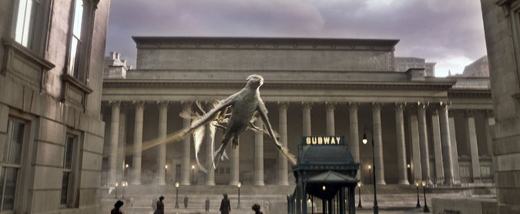
A thunderbird, one of the fantastic beasts of the film’s title. Credit Warner Bros.
When “Fantastic Beasts and Where to Find Them” opens on Nov.18, it will be the first time fans of J. K. Rowling’s wizards and witches will get to see her cast a cinematic spell that isn’t based on one of her novels.
Extending a beloved film franchise is a risk that can either thrill a loyal audience (“The Force Awakens”) or infuriate it (“The Phantom Menace”). With “Fantastic Beasts,” Ms. Rowling took on that challenge herself, writing an original screenplay that will commence a new five-film franchise in a new time, place and more mature tenor, reflecting both the multibillion-dollar franchise’s vast audience and the author’s political conscience.
David Yates, the film’s director — who also directed the last four Harry Potter movies — said that when he initially received the script, “I was a bit nervous opening the first page. Is it going to feel like Harry Potter again? Can I go back to Hogwarts?”
The new film does not go back to Hogwarts or even take place in Britain. Instead, the thoroughly British series here moves across the Atlantic and back in time to 1926 New York, when the city was riven by many of the same social fault lines of the current political moment, like extreme income inequality and xenophobia. Instead of a child hero, the film follows the adult Newt Scamander (played by Eddie Redmayne), the author of “Fantastic Beasts and Where to Find Them,” Ms. Rowling’s 2001 fantasy textbook, purportedly studied by Harry Potter and his fellow Hogwarts students.
In the film, the British “magizoologist” Newt arrives in New York and smuggles a magical briefcase full of strange beasts through customs. He discovers powerful American magic, terrifying threats and some friends: Jacob Kowalski (Dan Fogler), a working stiff who toils in a factory but yearns to be a baker; Porpentina Goldstein (Katherine Waterston), an astute officer of the Magical Congress of the United States of America, ; and Porpentina’s flirty, often underestimated sister, Queenie (Alison Sudol). “Fantastic Beasts” is indeed fantastical, but many themes and references, like the Magical Congress’s color-coded threat index, are pointedly contemporary.
“Things are happening now that are extreme and extraordinary in some way, and to not reflect that or to explore those things seems to be a missed opportunity, especially as our film is going to reach so many people,” Mr. Yates said.
Working without a novel was a mixed blessing, said the producer David Heyman, who optioned Ms. Rowling’s first Harry Potter book and helped shepherd the franchise to $7.8 billion at the worldwide box office. For the first time, he said, “people don’t know what’s going to happen.”
The challenge, said Greg Silverman, the Warner Bros. president of creative development and worldwide production, “is that you have to deliver what the fans are expecting, but you also have to deliver more.”
The first draft of “Fantastic Beasts,” Mr. Yates said, was “predominantly dark and intense and fundamentally more serious.” A subsequent version, he said, was “very broad and playful, and that felt quite young,” as if they were “just remaking the earlier films.” Then Ms. Rowling found her groove.
Since the 1997 debut of the novel “Harry Potter and the Philosopher’s Stone” in Britain (retitled “Harry Potter and the Sorcerer’s Stone” for American readers), the audience for the wizarding world has grown and, in many cases, grown up. The once-broke Ms. Rowling has become one of the world’s richest authors, a pseudonymous crime novelist and influential philanthropist. She has embraced her global platform, particularly online, where she has passionately critiqued Britain’s “Brexit” movement and Donald J. Trump.
In an essay posted online in June, “On Monsters, Villains, and the EU Referendum,” Ms. Rowling proudly declared herself a “mongrel product of this European continent” and worried that “nationalism is on the march across the Western world, feeding upon the terrors it seeks to inflame.” She added, “Look towards the Republican Party in America and shudder. ‘Make America Great Again!’ cries a man who is fascist in all but name.”
Through Warner Bros., Ms. Rowling declined to comment for this article, but according to her collaborators, her aversion to nationalist, anti-immigrant sentiments influenced the “Fantastic Beasts” script, an artistic choice the studio supported. “As a writer, she’s seeing the world take a different shape in front of her eyes,” Mr. Yates said, “which inevitably imbues itself on the subconscious and pours out into the writing.”
She set the new film on the eve of the Great Depression, when, as both Ted Cruz and Bernie Sanders have argued, income inequality last reached levels as extreme as today’s. In New York, the magical have been forced underground, where they live in fear of the “No-Majs,” the American term for Muggles. Inspired by the Salem witch trials, nonmagical “Second Salemers” hunt witches and teach children songs about flogging, burning and murdering them. There is “strict segregation between the No-Maj and wizarding communities,” Ms. Rowling wrote in a supplementary guide to North American magic. Intermarriage between the two is outlawed. Meanwhile, the wizarding community is torn between those who wish to hide and extremists who might prefer to subjugate the No-Majs.
In a promotional video for the film, Ms. Rowling said: “My heroes are always people who feel themselves to be set apart, stigmatized or othered. That’s at the heart of most of what I write, and it’s certainly at the heart of this movie.”
Mr. Heyman said that the film’s “incredibly humanist message” reflected the times but was not new. “The Malfoys and Voldemort were echoes of Nazis,” he said. “These are themes of Jo’s that have interested her forever. Now maybe it feels more acute or more relevant, but I don’t think we set out to make a political film with a capital P. This is an entertainment with themes that resonate across time. Alas, some of the issues we face in this film are timeless.”
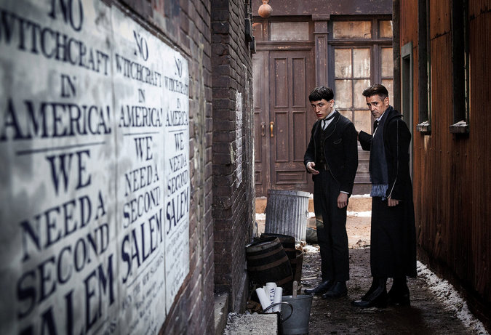
Ezra Miller, left, and Colin Farrell in “Fantastic Beasts and Where to Find Them,” one theme of which is xenophobia. Credit Jaap Buitendijk/Warner Bros.
On Twitter, Ms. Rowling has posted that “Voldemort was nowhere near as bad” as Mr. Trump. In the new series, the dark wizard Gellert Grindelwald is a more pernicious and modern threat, who manipulates impressionable followers, the media and prominent politicians.
“Unlike Voldemort, who was an angry brute, the next iteration is much more lethal,” Mr. Yates said. “He wants to win the hearts and minds in a way that’s quite beguiling and sophisticated, but his values are dangerous.” Such new nemeses are “able through sheer charisma and ability to inspire and hypnotize and carry the crowd, and take the world to a darker place. That’s where the next story is going.”
Already, Ms. Rowling and her team are editing the script for the second film, scheduled to begin shooting next year, and intolerance will continue to be a subject. “The movie we are about to embark on certainly continues that theme and strengthens it,” said the production designer Stuart Craig.
Mr. Yates was careful to emphasize that the new films were meant to be entertaining and delightful, but foremost are “fundamentally about how communities learn to live with each other or end up destroying each other,” he said. “The stories going forward have that ambition, in a way that’s not too earnest, and doesn’t take itself too seriously. There are enough negative values put out into the world, it would seem like a shame not to push out some good ones.”
A version of this article appears in print on November 6, 2016, on Page AR24 of the New York edition with the headline: A Jazz Age World of Fancy and, Yes, Fear.
https://www.nytimes.com/2016/11/06/movies/fantastic-beasts-and-where-to-find-them-preview.html
____________________________________________________________________

J.K. Rowling Says ‘Fantastic Beasts’ Grew Out of World Events (Interview)
By ANDREW R. CHOW NOV. 10, 2016
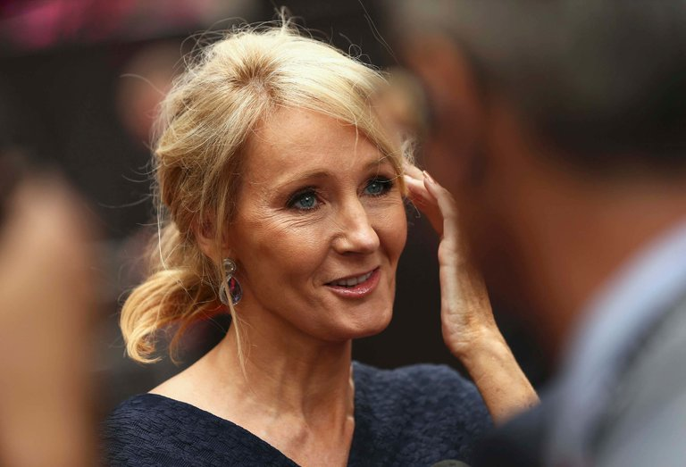
J.K. Rowling, the “Harry Potter” novelist, set her first movie in the young wizard’s universe, but some 80 years before he enters the scene. Credit Neil Hall/Reuters
Hours before the premiere of “Fantastic Beasts and Where to Find Them,” the author J. K. Rowling, acknowledged that she ground through several revisions of the screenplay, her first, and said the rise of populism around the world in recent years had influenced the story’s direction.
Ms. Rowling, the “Harry Potter” novelist, discussed the creative process behind the film at a news conference with members of the cast and crew on Thursday in New York. Warner Bros. is counting on the $180 million movie to be a hit, and four sequels are in the works.
“Fantastic Beasts” takes place in the Harry Potter universe but some 80 years before Harry himself enters the scene. Based on a “guide” of the same title that Ms. Rowling published in 2001, the story follows Newt Scamander (Eddie Redmayne), a British wizard whose study of magical creatures takes him to a version of 1926 New York, where economic inequality is high and wizards have been forced into hiding by an intolerant government. Xenophobia, authoritarianism and oppression are central themes.
“When I was asked, ‘Will you write more?’ at the back of my mind was Newt,” Ms. Rowling said. “I hope when people see the movie, they will understand that it grew out of things that are very important to me in the world at the moment.”
Ms. Rowling is a passionate social activist and cultural critic: In an essay in June, she wrote that Donald J. Trump “has the temperament of an unstable nightclub bouncer.” On Thursday, she declined to talk about Mr. Trump, saying, “Today might be a day to concentrate on some good things, and putting some good things out into the world.”
However, she did say that modern global developments informed her story set in the 1920s. “This period was threatening to become very dystopian. You were looking at the rise of a very dark force. I conceived the story a few years ago, and I think I was partly informed by a rise in populism around the world.”
As the director David Yates noted in a recent interview with The New York Times, Ms. Rowling wrote several drafts of the screenplay before finding the right tone, and on Thursday, Ms. Rowling described the revisions. “One of them was really dark. There was a lot of stuff in the sewers,” she said. “But that is always my process: I tend to generate a lot of material.”

Although “Fantastic Beasts” focuses on new characters, Ms. Rowling confirmed there will be a familiar face in the sequels: the headmaster Albus Dumbledore. She declined to answer a question about Dumbledore’s sexuality, a topic of much controversy and interest, and whether he would be openly gay in the follow-up films. “You will see Dumbledore as a younger man, and quite a troubled man,” she said. “We will see him in what I think is the formative period of his life. As far as his sexuality is concerned: Watch this space.”
Mr. Redmayne and Mr. Yates were in attendance at the news conference, as were the co-stars Katherine Waterston, Dan Fogler, Alison Sudol and Ezra Miller, and the producer David Heyman. Mr. Redmayne worked with animal handlers to prepare for the role, and the inventive creatures in the movie were brought to life by a combination of computer graphics, animatronics and puppeteering. “There were moments when you had to access your inner kid,” Mr. Redmayne said.
Meanwhile, Ms. Rowling, who published her first play, “Harry Potter and the Cursed Child,” to critical acclaim in July, has moved on to the next movie. “Last night, I was in kind of a bleak mood, bored on the plane, and I thought, I need to work,” she said. “I got out the second screenplay and did some work on that, and that made me feel a whole lot better.”
A version of this article appears in print on November 12, 2016, on Page C2 of the New York edition with the headline: Fantastic Beasts, Political Concerns. Order Reprints| Today's Paper|Subscribe
https://www.nytimes.com/2016/11/12/movies/jk-rowling-says-fantastic-beasts-grew-out-of-world-events.html?action=click&contentCollection=Movies&module=RelatedCoverage&region=Marginalia&pgtype=article

