A creative approach to fighting street violence: paint the barrio.

Mexican Government Asked Street Artists To Paint 200 Houses To Unite Community
A youth organization that’s been known to use graffiti as a means of expression has teamed up with the government of Mexico to rehabilitate Palmitas, a town in the Pachuca district. Under the moniker “Germen Crew,” the group painted 209 houses, or twenty-thousand square meters of facade, into a single rainbow mural.
According to streetartnews, the impact has been extremely positive: 452 families, or 1808 people, were affected by this project, resulting in violence amongst youths being entirely eradicated. The group, whose name literally means “germ crew,” have made community involvement a priority, which could partially explain the good results.
Link to story, photos, and video: http://www.boredpanda.com/crew-germen-graffiti-town-mural-palmitas-mexico/
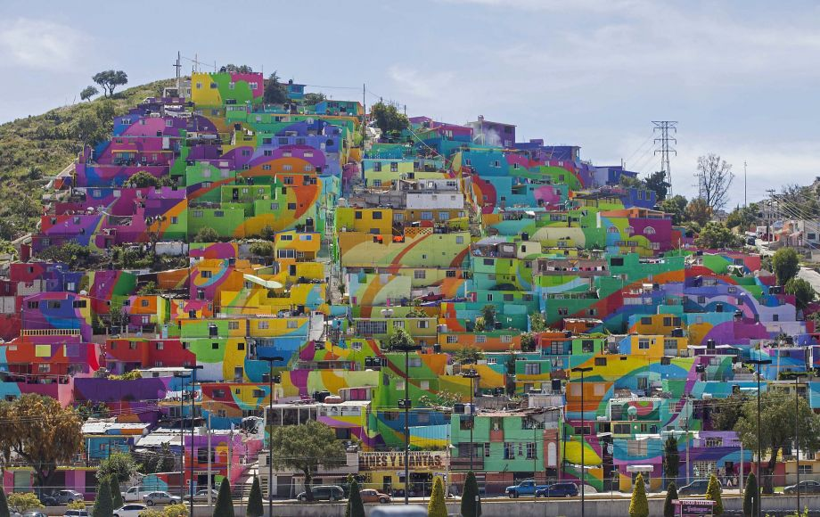
Photo: Sofia Jaramillo, Associated Press
PACHUCA, Mexico — A community project in central Mexico is bringing art to people’s homes.
A group of artists known as the Germ Collective have spent 14 months turning the hillside neighborhood of Las Palmitas into a giant, colorful mural in an effort to bring the working-class “barrio” together and change its gritty image.
Working hand-in-hand with residents, muralists have painted the facades of 200 homes bright lavender, lime green, incandescent orange — hues more commonly found in a bag of Skittles than in the drab, concrete-and-cinderblock neighborhoods where many of Mexico’s poor live.
Seen from afar, the individually painted houses combine to form a cohesive, if abstract, swirly rainbow design. Bright stripes that begin on one wall run across several homes before swooping into graceful curlicues.
It’s an homage to the wind: the city of Pachuca is referred to as “la bella airosa,” a Spanish phrase that loosely translates as “the beautiful breezy city.”
http://www.sfgate.com/world/article/Massive-mural-brightens-and-unites-Mexican-6419521.php

