Sample Reviews #2

‘Tomorrowland’ — a slow start, but the future is bright
By Mick LaSalle Thursday, May 21, 2015
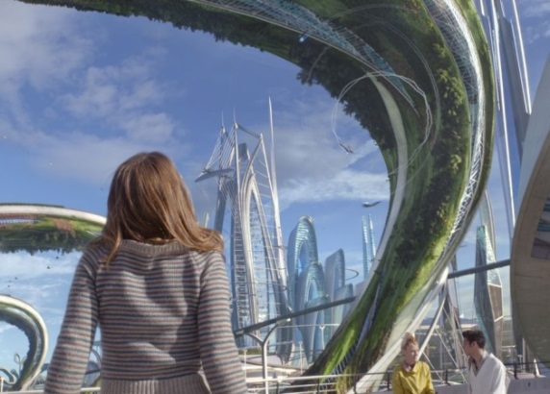
(Photo: Walt Disney Studios / Walt Disney Studios) Britt Robertson plays your average girl genius who stumbles upon another world. Now she has to save it, and ours too.
“Tomorrowland” deals in two futures: the one people imagined in the early 1960s and the one people imagine today. In the ’6os, despite a Cold War that threatened to turn hot and blow up civilization, people saw the future as a clean and gleaming place, with flying cars and monorails moving at the speed of light. It was a vision captured in the cartoon series “The Jetsons.”
Today, the future is generally portrayed as a postapocalyptic nightmare, with limited resources, little water and either no government or an all-pervasive, controlling government that makes life a living hell.
“Tomorrowland” is a plea on behalf of that earlier, more optimistic vision as having value in itself, the idea being that if people believe they are heading into broad, sunlit uplands, the chances are better that they will arrive there. And despite a first hour that sometimes seems as if the movie itself will never arrive anywhere, hold on. The future is bright.
Only about 10 percent of movies finish better than they start, but “Tomorrowland” is in that category. After a likable teaser, in which George Clooney and Britt Robertson are recording a message of some kind, the movie adopts a storytelling strategy that’s labored and unnecessarily mysterious. First we meet the Clooney character, Frank, as a little boy making a visit to the 1964 World’s Fair in New York. Next thing we’re in modern-day Texas for a long section about Casey (Robertson), a spunky 18-year-old girl with a gift for science.
For almost an hour of screen time, viewers are never quite told what is going on and, more to the point, they’re not made to care much either way. To hold audience interest, everything in the movie that looks like action is pumped to the skies, which only makes the storytelling more slow and plodding. Yet even at this early stage, the look, feel and atmosphere of “Tomorrowland” are appealing, and the glimpses we get of the place Tomorrowland — a city outside time and space — make us want to linger there.
The city looks like a cross between the Jetsons’ Orbit City and modern-day Abu Dhabi, only with things like levitating baby strollers and swimming pools that hang in the air. Flying traffic crisscrosses in every direction, with no discernible pattern or organization, but then that’s probably what our world would look like to someone from 200 years ago.
“Tomorrowland” doesn’t completely hit its stride until its two main characters, Frank and Casey, meet. He’s a former boy genius, and she’s a current girl genius. The two clash and collaborate; the story comes into focus, and suddenly the movie is a delight. You know those novels that make you slog through 50 slow pages, and then everything is OK? “Tomorrowland” is like that, only with movies you can’t adjust your reading speed.
Clooney is the linchpin, playing Frank with an anger and disappointment bordering on despair. This is not Clooney cashing in on some action-movie payday, so he can go back to his serious work. This is a real performance and, to the film’s credit, Clooney’s investment is supported by the script. Frank knows things, terrible things, that no one else knows, and it’s eating him up inside.
As Tomorrowland’s governor, Hugh Laurie functions as Clooney’s opposite number, a cynic insulated from emotional pain because he’s beyond caring. The script gives him the best lines, particularly a speech about apocalyptic movies (that is, other people’s apocalyptic movies) — a smart analysis of the public’s current fascination with doom.
Robertson is irrepressible and makes a bright contrast to Clooney’s bitterness, and Raffey Cassidy holds her own as a preternaturally precocious little girl.
The movie’s last hour is filled with several strong sequences, exhilarating to watch and gorgeous to behold, but these are best discovered in the moment. But the best — involving Paris, the Eiffel Tower and a rocket ship built in the late 19th century — deserves special acknowledgment.
In the end, “Tomorrowland” is as much about Edison’s and Eiffel’s vision of the future as it is about the Jetsons’. The movie is saying something worth hearing about the place the future holds, the concept and promise of it, in human existence. It’s an attempt to wrest that vision from the narrow fantasies of doom-peddling action filmmakers. That’s an attempt worth making.
Mick LaSalle is The San Francisco Chronicle’s movie critic. E-mail: mlasalle@sfchronicle.com Twitter: @MickLaSalle

Movies

‘Tomorrowland,’ Brad Bird’s Lesson in Optimism By A. O. SCOTT MAY 21, 2015
My son briefly had a youth baseball coach whose way of inspiring his demoralized players was to stand at the dugout entrance screaming at them to have fun. “Tomorrowland,” Brad Bird’s energetic new film, a shiny live-action spectacle from Disney, reminds me of that guy. There is nothing casual or whimsical about this movie’s celebration of imagination, optimism and joy. On the contrary: It’s a determined and didactic argument in favor of all those things, and an angry indictment of everyone who opposes them.
Just who that might be is an interesting question. The answers proposed by Mr. Bird and Damon Lindelof, his screenwriting collaborator, run the usual gamut: politics, bureaucracy, greed, bad teachers, dumb parents, a villain with a long black coat and a British accent. Mostly, though, the fault lies with humanity itself. We are wonderful creatures, capable of dazzling feats of invention and problem-solving, but we have a damnable tendency to get in our own way, to sell out and sell ourselves short.
Photo
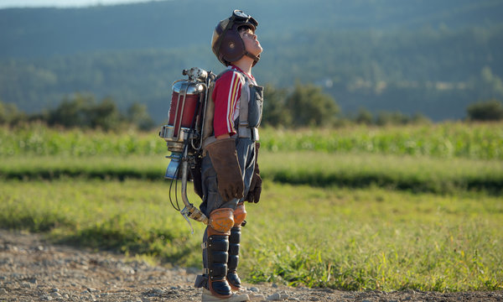
Thomas Robinson in "Tomorrowland." Credit Kimberley French/Walt Disney Pictures
In the past 50 years or so, according to the “Tomorrowland” timeline, we’ve succumbed to pessimism. Where we used to look to the future with hope and excitement, we now embrace decline and futility. Everything’s falling apart, and instead of making it better, most of us just wallow in gloom, especially when it comes to entertainment. A billboard advertises something called “ToxiCosmos 3,” and to those of us who groove on such visions of apocalypse and catastrophe, Mr. Bird has a message: Cut it out! To those of us who can conceive something better, the message is: Wake up and start dreaming!
There are some logical — and, I dare say, some ideological — contradictions here, and a more serious problem of tone. The filmmakers want to dazzle you, but they also want to teach you a lesson. In 1965, young Frank Walker (Thomas Robinson, who will grow up to be George Clooney) arrives at the New York World’s Fair with a big grin and a cool invention. It’s a jetpack made out of an old vacuum cleaner, and while it doesn’t quite fly, Frank figures that his hard work and can-do spirit will impress the dour judge (Hugh Laurie, earmarked for his subsequent bad-guy role) in the inventors’ pavilion. Asked what the use of his contraption is, Frank replies that it’s for fun, which is its own kind of utility. If people see that such a thing can exist, they’ll be inspired. They’ll believe in their own capacities, and in the general possibility of good stuff.
Photo
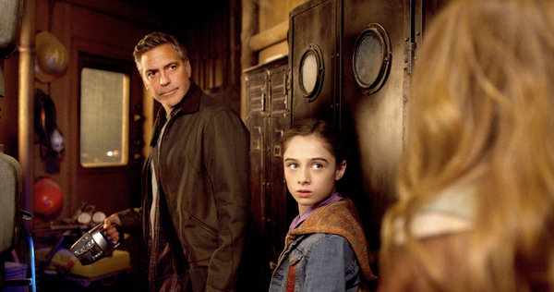
George Clooney, as the older Frank, with Raffey Cassidy, who plays Athena, a blend of Mary Poppins and Tinker Bell. Credit Walt Disney Pictures
That’s an excellent defense of creativity, and of the value of art, but it’s a defense that is advanced so bluntly and insistently that it gets in the way of the actual art. At the World’s Fair, Frank develops a crush on Athena (Raffey Cassidy), a girl, gray-eyed like her namesake goddess, who is (to keep the comparisons within the boundaries of the Disney universe) a perfect blend of Mary Poppins and Tinker Bell. Athena hands Frank a pin that is his ticket to Tomorrowland, a place founded by some of history’s greatest geniuses as a combination Utopian community, R&D lab and “Atlas Shrugged” theme park.
Later, in our own time, a similar pin will come into the possession of Casey Newton (Britt Robertson), a teenager whose irrepressible gumption is expressed through acts of sabotage at the NASA launch platform near her home in Cape Canaveral, Fla. She is motivated not by hostility to the space program — which used to employ her dad (Tim McGraw) as an engineer — but rather by rage that celestial exploration is being abandoned. She wants to halt the dismantling of the facility, a wonderfully futile gesture that marks her as a potential savior of Tomorrowland and a new recruit for Plus Ultra, the secret club of artists and smarties who populate it. She, too, meets Athena, and they fight off some nasty robots on the way to find Frank, now exiled from Tomorrowland and living out his days as a grizzled crank (i.e., as George Clooney) in a ramshackle house equipped with amazing gizmos.
I was tempted to affix a little trademark sign to the word “amazing” there. The effects in “Tomorrowland” fall short of that standard, but part of Casey’s job is to serve as a kind of on-screen shill, cuing the desired audience response by exclaiming “Whoa, that’s amazing!” or “Wow, incredible!” at regular intervals. And while some of the images are interesting, even startling — a visit to the Eiffel Tower, for instance — the action is more frantic than thrilling and the sense of wonder rarely materializes.
It gives me no pleasure at all to report this. I yield to no one in my admiration for Mr. Bird’s animated Pixar features — “The Incredibles” and especially “Ratatouille,” for my money one of the finest movies ever made about the pursuit of artistic excellence. And it’s important to note that “Tomorrowland” is not disappointing in the usual way. It’s not another glib, phoned-in piece of franchise mediocrity but rather a work of evident passion and conviction.
What it isn’t is in any way convincing or enchanting. Mr. Clooney is wry and gruff, and then earnest and amiable, in a role that dozens of actors could have played. Ms. Robertson is perky and panicky in the same way. Among the characters only Athena has any real distinction, and Ms. Cassidy is an intriguing performer, funny and a little scary in her composure. Everyone else, Mr. Laurie included (and Kathryn Hahn and Keegan-Michael Key partly excepted), would be better as a cartoon.
To some extent, that goes for the whole movie. Its enormous lapses in narrative and conceptual coherence — its blithe disregard for basic principles of science-fiction credibility — would be less irksome in the fantastical cosmos of animation. And it would look better, too. Tomorrowland looks less like a magical city of the future, or even the Disney environment it’s meant to evoke, than like an unusually clean and efficient airport, or the shopping mall beyond the multiplex where you’re seeing the movie.
Perhaps “Tomorrowland” should not be blamed for succumbing to the poverty of vision it works so hard to attack. Maybe the forces of negativity are just too strong. But it’s also possible that the movie is confused about how to imagine and oppose those forces. False cheer can be just as insidious as easy despair. And the world hardly suffers from a shortage of empty encouragement, of sponsored inducements to emulate various dreamers and disrupters, of bland universal appeals to the power of individuality. “Tomorrowland” works entirely at that level, which is to say in the vocabulary of advertisement. Its idea of the future is abstract, theoretical and empty, and it can only fill in the blank space with exhortations to believe and to hope. But belief without content, without a critical picture of the world as it is, is really just propaganda. “Tomorrowland,” searching for incitements to dream, finds slogans and mistakes them for poetry.
“Tomorrowland” is rated PG (Parental guidance suggested). Have fun, kids!
Directed by Brad Bird; written by Mr. Bird and Damon Lindelof, based on a story by Mr. Bird, Mr. Lindelof and Jeff Jensen; director of photography, Claudio Miranda; edited by Craig Wood; music by Michael Giacchino; production design by Scott Chambliss; costumes by Jeffrey Kurland; produced by Mr. Bird, Mr. Lindelof and Jeffrey Chernov; released by Walt Disney Pictures. Running time: 2 hours 10 minutes.
WITH: George Clooney (Frank Walker), Hugh Laurie (David Nix), Britt Robertson (Casey Newton), Raffey Cassidy (Athena), Tim McGraw (Ed Newton), Kathryn Hahn (Ursula), Keegan-Michael Key (Hugo) and Thomas Robinson (Young Frank Walker).
A version of this review appears in print on May 22, 2015, on page C1 of the New York edition with the headline: A Future Where Things Are Looking Up .
Rolling Stones film review: Tomorrowland By Peter Travers May 20, 2015

George Clooney blinds us with science in Brad Bird's Spielberg-ish sci-fi blockbuster
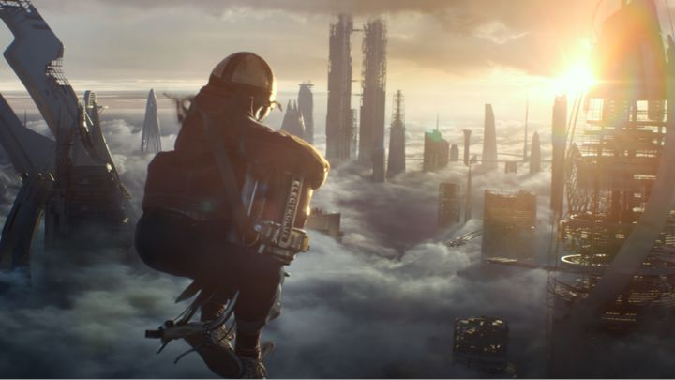
Thomas Robinson as Young Frank Walker in 'Tomorrowland.' Film Frame/Disney
No cynicism, no snark. What! In box-office terms, that usually translates into no chance. Yet Brad Bird's Tomorrowland, a noble failure about trying to succeed, is written and directed with such open-hearted optimism that you cheer it on even as it stumbles.
Bird has kept a tight lid on plot details. And rightfully so. Discovering Tomorrowland fresh is integral to its purpose. But let's say this much. George Clooney plays Frank Walker, a scruffy, grumpy inventor who has closed himself off from the world on his New York farm. But when we first meet Frank, played as a kid by Thomas Robinson, he's on a visit to the 1964 World's Fair and bursting with fun and ideas. He tries to sell scientist David Nix (Hugh Laurie) on a primitive jet pack he devised out of his best dreams. Nix shuts him down. Clooney is so skilled an actor that we never lose sight of young Frank in his performance. His childlike awe of the future is always detectable under his hard shell.
The same could be said of Bird in his animated classics (The Iron Giant, The Incredibles, Ratatouille) and of his co-screenwriter, Damon Lindelof, who helped create the mysteries of Lost. For them, wonder keeps defeatism at bay.
Where did things go wrong for Frank and for the world he shares with us? That's the film's abiding theme. And Tomorrowland, the beautifully rendered symbol of a utopia where the best minds gather to plan that future, drives all the characters.
Long ago, Frank had met a girl, Athena (the amazing Raffey Cassidy), who gifted him with a magic pin that zapped him into Tomorrowland. With Frank expelled for his sins (I'll never tell), Athena gives her last pin to Casey (a lively Britt Robertson), the daughter of a NASA engineer (Tim McGraw). Her dreams of being an astronaut died with the space program.
For Bird, Tomorrowland is a concept corrupted, not just by evil robots who smile like Tom Cruise, but by our own casual acceptance of a coming doomsday. In The Incredibles, heroes are forced to suppress their powers. In Tomorrowland, scientists are asked to profit from a sick world, not to save it. Bird calls bullshit on that. Naive? Maybe. But even as Tomorrowland sinks into sermonizing (show is always better than tell), Bird flies in the face of PG family fun by asking audiences of all ages to actually think.
Read more: http://www.rollingstone.com/movies/reviews/tomorrowland-20150520#ixzz3oeq3PZVP
Follow us: @rollingstone on Twitter | RollingStone on Facebook

Discussion Questions (which might relate to quiz questions) You don’t need to write down your answers to these, but be prepared to discuss them and/or write about them in class.
- Annotate the reviews above so you can find the following elements easily (maybe use the numbers to annotate):
- thesis-type sentences (where the reviewer makes a claim about the film’s quality and/or meaning). There is likely to be more than one in any given review.
- Discussion of the film’s strengths and/or weaknesses
- Plot overview and/or details
- Background about the filmmaking team (director, actors, cinematographer, etc) and/or background about the topic, including other films of this type.
- Cultural or historical context that helps us understand the film
- For each review, decide on your reaction. That is, if you were sitting in a café after the film discussing it with this reviewer, what would you say about his/her opinions as expressed here?
- Consider the photos each reviewer decided to include. What does each emphasize about the film? How are they likely to influence the reader? Which images (among all that you remember of the film) would you choose if you were reviewing this film?

