Philosophy 113
Existentialism and Phenomenology
Prof. Carlos A. Sanchez
Fall 2012
Mondays, 7:00-9:45 p.m.
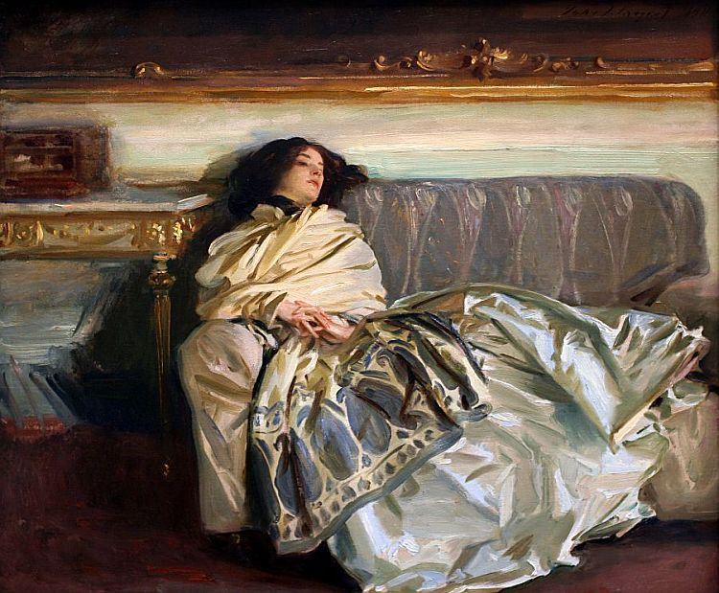

In this course we will think about being, time, death, language, and the radical solitude of individual human existence.
We will read the following texts:
- Maurice Blanchot’s Thomas the Obscure
- Emmanuel Levinas’ Time and the Other
- Jacques Derrida’s The Work of Mourning
- Martin Heidegger’s Ontology: The Hermeneutics of Facticity
- Jean-Paul Sartre’s Nausea
There will be weekly write-ups, a midterm exam, and a final paper. Contact Prof. Sanchez with any questions: carlos.sanchez@sjsu.edu

