

Newsletter:
Department of Philosophy
San Jose State University
October. 2005

Editor: Tom Leddy

New Faculty Member!

Anand Jayprakash Vaidya was hired as an Assistant Professor starting this Fall. He was born in Evanston, Illinois, and raised in Texas, Saudi Arabia, India, and Germany. He lived in Saudi Arabia from 5 to 15. He left the country with his mother shortly after the first Gulf War, and moved to California. Anand initially studied existentialism, phenomenology, and logic at Humboldt State University in Arcata, CA. With a growing interest in logic he transferred to the University of California, Los Angeles. There he studied logic, philosophy of language, and the metaphysics of modality. After a brief return to India in 1999 he entered graduate school at the University of California, Santa Barbara.

His graduate research focused on epistemology, metaphysics, and the philosophy of mind & psychology. He wrote his qualifying exam on Modal Rationalism, a thesis concerning the relation between conceivability and possibility that is often used to argue against materialist conceptions of mind. His dissertation The Epistemology of Metaphysical Modality is an investigation and evaluation of classical and contemporary accounts of epistemic access to metaphysical modality. Anand received his Ph.D in 2005 from UCSB. His primary research interests are in metaphysics & epistemology (especially of modality), and philosophy of mind & psychology. His teaching interests include: history of philosophy (ancient through contemporary analytic), applied ethics, meta-ethics, and logic.

Outside of academic research and teaching you can find Anand doing any of the following: reading, cooking, playing guitar, hiking, running, yoga, weight training, traveling, chess, ping-pong, and pool. [This account is taken from Anand’s SJSU web site.]

Outstanding College Alum Nominated
Prof. Manning nominated John Sullins, Associate Professor of Philosophy at Sonoma State University, for the Gold Award (outstanding college alum in last 10 years.) John recently published “Building Simple Mechanical Minds: Using LEGO® Robots for Research and Teaching in Philosophy,” in Cyberphilosophy, pp. 104-117, Blackwell Publishing, 2002.
Outside Philosophy, John completed the Masters Fencing Program at San Jose State University (1994). He teaches foil, epee, sabre, and various historical arms. He has trained in fencing pedagogy under many skilled fencing masters including Maestro William Gaugler and Military Master at Arms Ralph Sahm (1986 to 1994). He has taught at numerous fencing schools and programs since the mid 1980's and was a cofounder and manager of the Tri Cities Academy of the Sword in Binghamton, New York 1998-2002. [This material was taken from the Sonoma State University web site].

ISREE News
In 2004-5 the Governing Board of ISREE [Institute for Social Responsibility, Ethics, and Education] updated its charter approved by the five year review committee. Professor Hadreas [currently the director of ISREE] put together a pilot business ethics seminar and delivered it on-site at Sims Metal America, Nov., 2004. Janet Cohen and George Archambeau, CEO's of Silicon Valley's Project Hired, were brought to SJSU and mentored (approx.) 200
students on social entrepreneurship. The ISREE also co-sponsored the annual
Ethics Bowl and the Villemain Lecture.
The 13th Annual Francis Villemain Lecture was given by Prof. Emily Robertson of Syracuse University on Feb. 25: “Public Reason and the Education of Citizens.” Prof. Michael Katz coordinates this series in Philosophy of Education
Memoir of Early Days at SJSU

I was at San Jose State in 1964 when there were two marvelous philosophy professors there, Arturo Fallico and Jay McCullough. I ended up getting a PhD in philosophy from USC in 1977, and then dozing through a software career until retiring this January.

I was wondering if any lore about Fallico and McCullough was still around when you got to San Jose State. I believe that Fallico was from Italy and had studied with Croce. He was an artist himself and wrote a book on art and existentialism. [Art and Existentialism, 1962]
[“Josephine F. Fallico, who had been living in the Mt. Eden Road area of Saratoga, died Jan. 1, 2001, following a long illness. She was 88. Born Sept. 17, 1912 in Chicago, Ill, Fallico came to California with her husband, Dr. Arturo B. Fallico, in 1949. She was a social worker with Santa Clara County for many years. Survivors include daughter Julie Di Perna of San Jose and sons Franc Fallico of Anchorage, Alaska, Pete Fallico of San Jose and Arturo Fallico Jr. of Saratoga.” [This information was taken from the Saratoga News Obit. column Jan. 24, 2001 – ed.]
McCullough was by far the most enlightened professor I ever had, and the most enlightened person I've known, except for my father. He was a scholar of Asian philosophy, had Fulbrights in India and Japan, but published nothing. He was a delightful mixture of Bodhidharma and HL Mencken. He died in the late 1960's.

I have always thought of San Jose State as a very friendly school.

I took no classes from Fallico and only spoke to him once, but he seemed like a very fine man, and McCullough liked him a lot.

McCullough taught Indian and Far Eastern philosophy, but I only had his Intro to Philosophy class. There was an Eastern philosophy club that formed around him, and they sponsored speakers, including Fallico and Alan Watts.

At the time, there was a class evaluation guide on campus prepared by students from evaluations written by students. It summarized McCullough as "a sage". So I wasn't the only one he impressed.

McCullough reminds me of the great Zen Master Ikkyu.

As I said, he published nothing. As he quipped one day in class, "Socrates never published, Jesus never published, Buddha never published, and come to think of it, I've never published either."

He was amazed at the ambition of intellectuals, and said that all he needed was to "drink beer, make love, and walk barefoot in the sand."

He had a Fulbright in Japan and spent time in a Zen monastery. He described his Satori experience. He had had a sumptuous meal in Tokyo and was walking home when he saw a prostitute. He said, "The problem was that I didn't have any money." But that was the occasion of his awakening, which he described as seeing that "All you have to do is be yourself." A very simple and perhaps disappointing statement, but it is in fact very profound.

He also had a Fulbright in India. He said that in the hotel in India, the bellhop, hoping to get a larger tip, said, "I love Jesus." McCullough said, "But I'm not a Christian." The bellhop asked him what he was. McCullough said that he was interested in Buddhism. And the bellhop said, "I love Buddha too."

He didn't like the social scientists' reductionist approach to religion. So when a lost coed came into class one day and asked if it was Sociology 101, he said, "Please, call me illegitimate, but not a sociology professor."

He was very skeptical about the self-aggrandizement of activists. I wore a peace button at the time, and he would make disparaging remarks about people who wore peace buttons, and then he'd wink at me.
One day I asked him to endorse something, and he said, "I don't even endorse myself."

I was at San Jose State only for the spring semester 1964. I started at UC Santa Cruz In the fall of 1965 and transferred to UC Santa Barbara for fall 1967.

The last time I saw McCullough was at the beach in the summer of 1967. He was walking towards the beach with his family. I told him that I was going to Santa Barbara in the fall, and to get his goat, I said that Bishop Pike was there. (Bishop Pike [Episcopal] was the kind of social gospelist that McCullough disliked.) He said, "Oh yes, Bishop Pike, I'll have to cross myself and drink some holy water. Speaking of holy water, where can I buy some beer?"

Fred Strohm

More information on McCullough: “My accidental mentor was professor Jay McCullough. I met him at San Jose State in 1957. Through him, I became familiar with Alan Watts, who I actually met in 1960. I attended several of his private seminars over the next few years. I lost track of Dr. McCullough after graduation, but while reading Professor Herbert V. Gunther's book, The Tantric View of Life, I noticed that the book was dedicated "To the memory of J. R. McCullough." I wrote to Prof. Gunther, and in his reply he remarked on what a good teacher Dr. McCullough was. When I think back on how my consciousness was changed so dramatically by a rather incidental experience, I'm still amazed.” Kenneth Savickas Concord, Calif. This letter appeared in Parabola Magazine, “Reader’s Forum,”
Fall, 2000 http://www.parabola.org/magazine/forum/2503teac.php4]

The Shapiro Prize winner for Spring 2005 was Al Frankowski

The Temple Prize winner for Spring 2005 was James Burkhouse

The Lydia A. and George V. Pinto Scholarship for Fall of 2004 went to Sarah Fields
Teaching Assistants in Fall 2005: (Graduate Students who teach their own class.)

Fern Alberts
Billy Gear
Janet Giddings
Krupa Patel
Bill Quigley
Sara Rettus
Shari Sharoki
Phillip Williamson

ETHICS BOWL

The Ethics Bowl team will be participating in a regional
competition at CSU Northridge in December and in the national competition in
Jacksonville, Florida, in March.
There will be an Ethics Bowl event put on by the Philosophy Department during Academic Integrity Week in the Fall. The bowl event will involve “a debate between members of the philosophy department and the National Hispanic team, which will be discussing students without Attention Deficit and Hyperactivity Disorder using the drug Ritalin to increase their academic abilities. They will also discuss if it is acceptable for police to lie during interrogations.” Spartan Daily News. Sept. 18, 2005 Cheeto Barrara “University Continues its Fight Against Cheating.”
Philosophy Club

The Philosophy Club has numerous events planned for the current semester. From our “philosopher of the week” to a debate on whether or not computers will be alive, we are trying to do philosophy in varied and interesting ways. The “philosopher/topic of the week” lays claim to a piece of the department’s hallway where people may find numerous biographical quips, informative articles and pictures that prepare them for a discussion that occurs during our meetings. Some of the upcoming (not a comprehensive list) philosophers that will take the center stage are: Hannah Arendt, Karl Marx, Ayn Rand and Ortega y Gasset.
The hope of centering on a specific topic or philosophy for a week is to expose philosophy students to as many different and underrepresented philosophers and topics as possible. To be notified of all upcoming events send an email to sjsuphilosophyclub@gmail.com and ask to be added to our Google group. See you during the semester, Kevin.

Geist – A Graduate Journal of Philosophy

Geist is an academic journal sponsored by The Symposium, SJSU Philosophy Club, in cooperation with the Department of Philosophy at San Jose State University. The journal is focused on publishing philosophical papers by undergraduate and graduate students from SJSU and the greater academic community, and is published every Spring semester. “The purpose of the journal is to promote the study of philosophy. It also provides students the opportunity to publish their work for the first time. Graduate students are highly encouraged to send in their work.” All philosophical paper topics are accepted. All papers are reviewed anonymously.

Vol. VII, Spring 2005 was edited by Trung Le. Associate editors were Sara Rettus, Phillip Hadley, Krupa Patel, Phillip Williamson, Kevin Fox, and Tanzeen Doha. Layout was by Melikamp and cover by Annie Bao. The journal was made possible by funds provided by the Associated Students of SJSU. This time the four articles were all from students outside our university. They covered such topics as the American Dream, quasi-realism, abstract classes, and Bachelard’s history of science.

The deadline for submission for the next journal is March 1, 2006. See the back page of the journal or the department web site under the philosophy club for submission guidelines. Contact: sjsu_philosophy_club@yahoo.com

Philosophy at the Theatre

About forty members of the Philosophy Department went to watch Hannah And Martin, at the San Jose Repertoire Theatre, May 2005. The play focused on confrontations between two philosophers: Hannah Arendt and her mentor Martin Heidegger. Professors Peter Hadreas and Tom Leddy led a discussion afterwards for interested members of the audience: the actors and the director were also present to answer questions. The Philosophy Club organized this event.

Department Weekend in Arnold

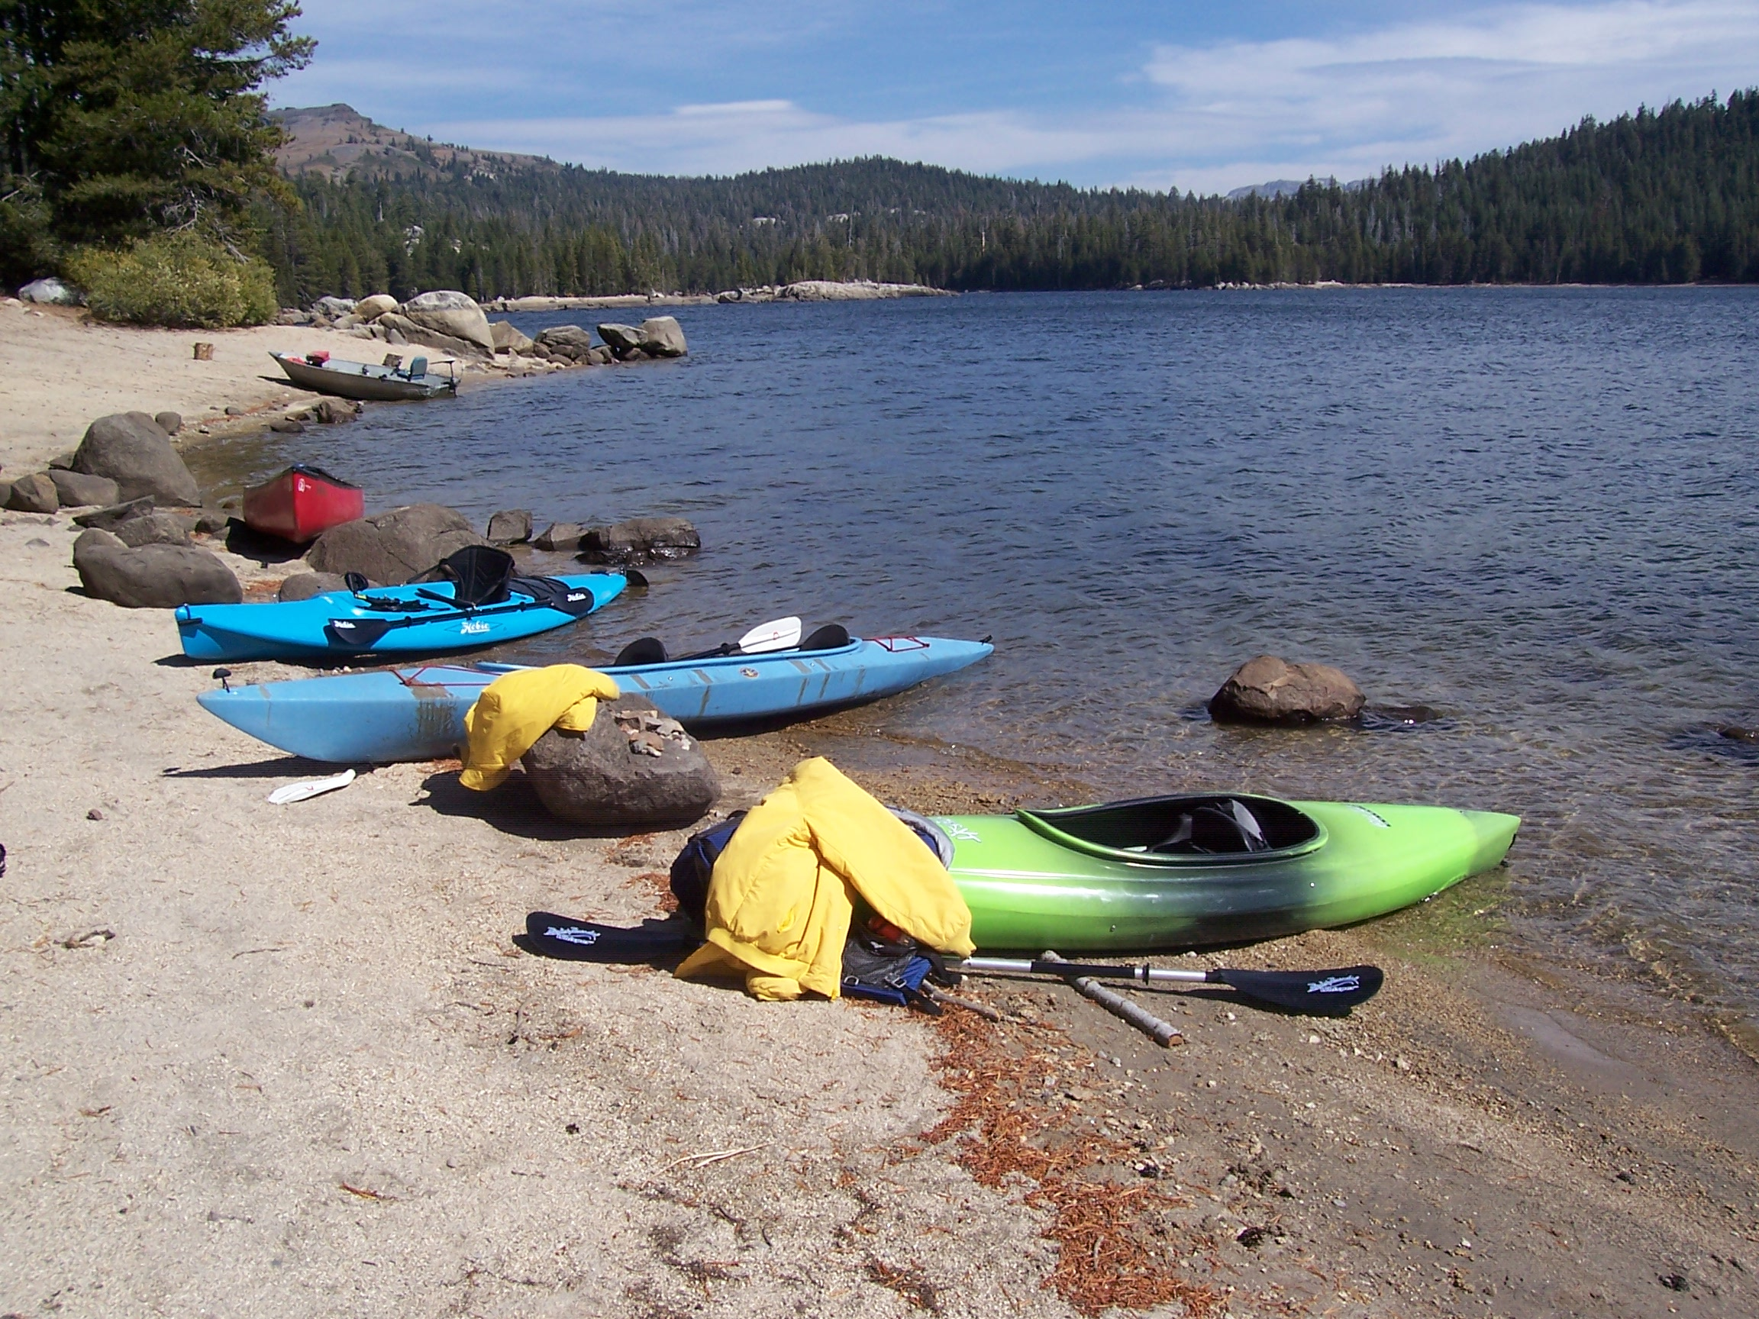
Department Armada at Lake Alpine

Several members of the Department met for an annual weekend in Arnold, CA. in late September. Wine-tasting, boating, and hiking were among the activities pursued.

SPRING 2005 SJSU PHILOSOPHY DEPARTMENT ALUMNI CONFERENCE

“The Any Topic in Philosophy Conference” Conference was held
Saturday, April 23, 2005 at
San Jose State University in the University Club

In the morning, Christer Swartz, alumnus, spoke on “Postmodernism’s Risk of Irrelevance: The Return of the Narrative” From his web site: “I graduated from San Jose State University in 1987 with a Bachelor of Arts degree in Philosophy. After that I moved back to Sweden and worked for a government-run institution caring for autistic children for half a year. I then meandered through Europe and the Middle East for a while before returning to California in 1989 to begin my bright career in computer Internetworking at the then-small startup company, Cisco Systems.” Christer went on to work for a variety of tech companies, most recently for Franklin Financial, a mortgage-broker based in San Jose, running their national data network. Christer did graduate work in Theology at Fuller Seminary between 1990 and 1996.
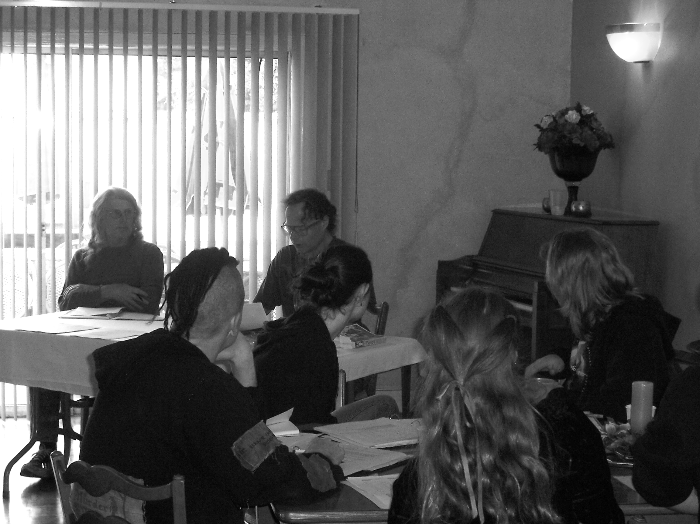
Christer’s talk was followed by Prof. Janet Stemwedel, “Honesty is not enough: A minimal set of values required for successful science.”

During lunch (provided free for participants by the Philosophy Department) we had the brief annual meeting of the SJSU Philosophy Alumni Association, George Pinto chairing.

In the afternoon, Prof. Tom Leddy gave “Lu Chi’s Wen Fu: an Ancient Chinese theory of Poetic Creativity.” This was followed by a musical interlude by Professors Rita Manning and Peter Hadreas.

After a break, Reuben Rutledge, alumnus, gave “The Phenomenology of Vasubandu.” [Vasubandu was a Buddhist philosopher 280-360 A.D.] Reuben is at the California Institute of Integral Studies in the Asian and Comparative Studies program. His specialties are South, Central, and S.E. Asian Studies.

Sara Rettus, grad. student, SJSU, then gave her “Beginning in the Timaeus.”

The conference ended with Eric Meece, alumnus, “Neo-Platonism and Alchemy: the Forgotten Philosophy.”

This was followed by the Annual Philosophy Department Banquet at Eulipia. There, various awards were given out, and we took turns trying to define “love” [just kidding].

Conference

Colloquium Series and Other Talks

Oct. 5, 2004, Peter Hadreas “Husserlian Phenomenology and the Secret Truth of Prozac”

Nov. 9, 2004, Graham Priest,
Boyce Gibson Professor of Philosophy, University of Melbourne, Australia

“Structure of Emptiness”
In his colloquium paper, Professor Priest dealt with a central notion in Buddhist philosophy, “coming at the topic in a very Western way”.

Professor John Searle, Mills Professor of Philosophy,
University of California at Berkeley, gave a talk titled “On Social Reality” in Spring 2005. The talk was well attended, and Searle was his usual scintillating self.

GETTING A FULL-TIME JOB TEACHING IN A COMMUNITY COLLEGE
by Wayne Yuen

Breaking into a full-time position involves a bit of timing and a bit of luck, and a lot of persistence, or someone like [Prof.] Rita [Manning] who is good at badgering you. Honestly, the first step is getting your foot in the
door. Work part-time EVERYWHERE you can. Be friendly with your colleagues as best you can, and get to know the deans of the divisions that the philosophy/religious studies dept is in. If you can finagle it, have THEM do your in class teaching observations. ---- thats my BEST piece of advice...not all the Deans are willing to do this, but sometimes you'll get one.

Then start doing the math. Places where the full-time faculty have a few years before retirement are GREAT places to stay. Do everything you can to stay on these school's radar. You really have to vulture for full-time positions, since once a person gets one, they typically don't give it up unless they get a better offer, or retire. Then when the position opens up, apply apply apply. Have Rita badger you into doing this. She did it for me.

Check the chancellor's office website for openings in positions every semester. http://www.cccco.edu/

Try to be active in the administration if opportunities come up, but opportunities for activities like that don't come up very often for part-timers. Oh, and go to the meetings at the beginning of the semester if you can. Anything you can do to grab the attention of the
Dean, and the other professors in the division is good (as they will be on your hiring committee most likely).

Finally.... if you do get that interview, make sure you have ideas. Ideas about what you would like to see at the college. Ideas for new courses. Ideas for cross-curricular teaching strategies. Anything that makes you more appealing... but don't make it sound like you're going to rewrite the catalog or anything.

And most importantly, be yourself, don't try to be what you think the committee wants. At the CC level, its important to be friendly, and not too airy and academic. They're looking for people to teach students who are fresh out of high school, and without the skills that they need to succeed at the university level. If you're not approachable and friendly to the committee, then they have little reason to expect that you'll be approachable to students.

Feel free to email me if you have any more questions... I'll try to answer them the best I can.

FACULTY NEWS

Noam Cook has been on the Committee on Philosophy and Computers for the American Philosophical Association. He is the Secretary for the Society of Philosophy and Technology. Noam organized a special session for the SPT at the APA meetings in San Francisco, “Computers and the Mediation of Human Experience. Andrew
Feenberg (Simon Fraser University) presented his paper, “Online
Community: It’s Real and It’s
Happening” and John Sullins (Sonoma State University, CSU) presented a
paper entitled, “Moving Beyond ourBiology With Robotics Technology.” Prof. Janet Stemwedel chaired.

Peter Hadreas writes: My book, A Phenomenology of Love and Hate, is at publishers’ referees. A fantastical dialogue I wrote a few years ago, “Aristotle and Machiavelli Interviewed on Wall Street Week Under Review,” has been published by Business Ethics: A European Review. Vol. 14, No. 3. Fall, 2005. I read my paper, “Husserlian Phenomenology and the Secret Truth of Prozac,” at meetings of Society for Phenomenology and Existential Philosophy in Memphis, in Oct. 2004. This paper was accepted for publication by the medical school journal, Philosophy, Psychiatry & Psychology, pending revisions.
Travel log:
Cathy and I have had the extreme good fortune to travel a lot in the past nine months. Last January, some of us went to the top of Mount Kilimanjaro. The peak is 19,341 feet above sea level. I decided around 17,500 feet that a lesser view with the continued possibility of philosophizing was more interesting than a better view and cerebral hemorrhage. At 17,500 feet I was still pretty elevated. In late May, we went to the island of Chios, Greece, the legendary birthplace of Homer. Continuing the trip, in June, we went to Jerusalem. And in August we went to the magnificent, if slightly crazy, surreal gardens in the jungles of Mexico, called Las Posas.

Tom Leddy’s piece, “The Nature of Everyday Aesthetics,” was published as Chapter 1, in The Aesthetics of Everyday Life, ed. Andrew Light and Jonathan M. Smith (Columbia University Press, 2005) 3-22. Also his “A Defense of Arts-Based Appreciation of Nature,” is in the current issue of. Environmental Ethics vol. 27, 299-315. He also published a review of Donald Kuspit. The End of Art in The Journal of Aesthetics and Art Criticism. 63:1 (Winter, 2005) 85-86.

During his sabbatical in Fall 2004 Tom was working on Ancient Aesthetics, with a particular interest in Ancient Chinese aesthetics. He gave a paper in this area: “Lu Chi’s Wen Fu: an Ancient Chinese theory of Poetic Creativity” for the Spring Alumni Conference. Tom also participated in the APA meetings in San Francisco, commenting on Amy Coplan’s “Catching Character’s Emotions,” which used cognitive psychology to discuss the expression of emotion in film.

Elected to the Academic Senate in the Spring, Tom hopes to learn more about the inner workings of SJSU .

Tom had a great time teaching his seminar on Kant in the Spring and is currently enjoying his courses in Aesthetics, Ancient Philosophy and Philosophy of Art. He appreciates receiving the “Teacher of the Year “ award from the Philosophy Club!

Tommy Lott gave a paper “Cloning as Modernization Metaphor: Is Counter Hegemony Possible?” at the Conference on Cloning Culturing Cultures; Normativities, Homogeneities, and the Human in Question, University of California, Irvine, May 13, 2005. He also gave “The Intellectual Odyssey of John Coltrane,” in the Symposium on John Coltrane and Black America’s Quest for Freedom: Spiritual and Music at Northeastern University, Oct. 1, 2005. In addition to teaching at SJSU Tommy is Visiting Scholar at the Beatrice M. Bain Research Group, University of California, Berkeley. The Research Group focuses on issues of women and gender.

Bill Shaw edited a
new scholarly edition of G. E. Moore's 1912 book Ethics for Oxford University Press. Although Moore's book is his only sustained work in moral
philosophy after Principia Ethica (1903), it had fallen out of print. The new edition was released this month.

In August Prentice-Hall published a new edition of
his co-edited anthology, Readings in the Philosophy of Law.

Bill and Anand will be coaching the Ethics Bowl team this year.

Barbara Scholz is gone for the year to work on a book with her husband Geoffrey Pullam and James Rogers, a computational and mathematical linguist and a professor of computer science at Earlham College, to complete a book, “New Logical Foundations for Linguistics,” on model-theoretic syntax, a new framework for linguistic theory grounded in formal logic and applied to problems in syntactic theories. All three will be fellows at the Radcliffe Institute for Advanced Study at Harvard University.

Janet Stemwedel writes: at the Biennial meeting of the Philosophy of Science Association in Austin, TX
(November 2004) I was co-organizer of a Symposium session on Strategies of Modeling in Biology and Chemistry. As part of that session, I presented a paper, “Getting More With Less: Experimental Constraints and Stringent Tests of Model Mechanisms of Chemical
Oscillators.”

Then, in August, I went to Knoxville, TN for the International Society for the
Philosophy of Chemistry Ninth Summer Symposium. After presenting my paper, "Reaching for the Molecules in Chemical Explanations", I got a chance to discuss philosophy while hiking on the Appalachian Trail.

When I'm not off giving papers, I stay busy teaching philosophy of science
online and facilitating discussions at SJSU's Socrates Café.

You can learn much more about Janet at her impressive web site http://www.xanga.com/stemwedel

Rick Tieszen writes: A collection of some (fifteen, to be exact) of my essays, under the title Phenomenology, Logic, and the Philosophy of Mathematics, has just been published by Cambridge University Press. Two papers are forthcoming: “Consciousness of Abstract Objects” will appear in Phenomenology and the Philosophy of Mind (Oxford University Press), D. Smith and A. Thomasson (eds.), and “After Gödel: Mechanism, Reason and Realism in the Philosophy of Mathematics” will appear in a special issue of Philosophia Mathematica on the work of Kurt Gödel. I am the guest editor of this special issue, which will include six essays in all. A long review of the first English translation of Edmund Husserl’s Philosophy of Arithmetic will also appear in a future issue of Philosophia Mathematica. I have been invited to speak in December at a symposium on the work of “Hermann Weyl as Epistemologist” at Université Aix-en-Provence in France. I have also been invited to speak at a Group Session on “Einstein meets Husserl” at the 2006 American Philosophical Association (Pacific Division) meeting.

I thoroughly enjoyed teaching the Knowledge & Reality class on the philosophy of time last Spring semester, and I had a roomful of enthusiatic students helping me think about the issues. I plan to write on the subject of time at some point. At the moment, I’m enjoying my logic seminar on “logics of mental phenomena” and trying to find time for some of my extracurricular activities (such as hiking).

STUDENT NEWS

Dale Andrade was officially sworn into the State and Federal Courts of
California as an attorney.
Sarah Stillman was elected A.S. Vice President. She is also a student representative on the Academic Senate. Heading for Philosopher-Queen….

The editor is eager to publish materials about alumni: please send to tle403@aol.com or Tom Leddy, Department of Philosophy,
1 Washington Square, San Jose State University, San Jose, 95192 -0096

Melissa Burchard, M.A. Philosophy 1990, has a publication in the much-used on-line The Internet Encyclopedia of Philosophy “Feminist Jurisprudence.” 2005. Melissa belongs to the advisory committee of the Radical Philosophy Association. She gave a paper at the Association for Feminist Ethics and Social Theory Conference in Clearwater Beach, Florida, 2005, “Slippery
Agency: Sex, Fluidity, and Paradigms of Control”

Colin Caret is a philosophy graduate student at the University of Connecticut. At the Pacific University Undergraduate Philosophy Conference in April, he commented on a paper by John Hemmerich, “Open-mindedness and the Committed Character of Belief.”

Lorenzo Deveza wrote to tell us he will be attending graduate school at UC Davis in the Master’s of Science Program, and has been granted full funding. He is studying Biomedical Engineering and is focusing on musculoskeletal biomechanics.
ldeveza@hotmail.com

Al Frankowski is in the Ph.D. program in Philosophy at University of Oregon.

Cynthia Hatfield
graduated from our department in the early 90s writes May 17, 2005 from Kabul that for the last two
two years she has been working on country elections for the United Nations and the International
Organization for Migration. “My first post was in Brussels (focusing on migration issues), then Pakistan (voter education for Afghan refugees), then Jordan (Iraq Election). The Jordan mission finished in March and I was looking forward to a long vacation… But I was home in Brussels for a week then the UN called and offered me a post in election procedures. I'm now here in Afghanistan for the next eight months, drafting the framework for the upcoming Parliamentary elections. What's put in place now will be used as the guide for future elections here.”
Ramon Jimenez gave a paper at the Association for Practical and Professional Ethics, February 26-28, 2004 Cincinnati, “The Shield Association: To Preserve and Improve Our Law Enforcement”

Ginny Lin, who is now at the Institute of Integral Studies, chaired a session on “Language, Mathematics, and Comparative Philosophy, March 26, 2005 at the APA Meetings in San Francisco. Fern Alberts, a student in our department, was a discussant.

Scott Stroud published “Ontological Orientation and the Practice of Rhetoric: A Perspective from the Bhagavad Gītā,” Southern Communication Journal, 70 (2), 2005, 146-160. “Viciado em suas próprias Inclinações? Kant sobre a Propensão do Mal,” Impulso: Revista de Ciências Sociais e Humanas (in Portuguese), 15, 2004, 23-33. “Resurrecting Kant’s Postulate of Immortality,” Death and Anti-Death: Two Hundred Years after Kant, Fifty Years after Turing (vol. 2), 2004, Charles Tandy (ed.), (Ria University Press) 253-275. and “Narrative as Argument in Indian Philosophy: The Astāvakra Gītā as Multivalent Narrative,” Philosophy and Rhetoric, 37 (1), 2004, 42-71. He also gave eight presentations at various conferences.

David Nathan Taylor wrote

“Almost forty years ago, I graduated from SJS
(1967) in Philosophy, then challenged and passed
the Master’s Exams before completing even one
Master’s course. I attribute my success to my great teachers. I then completed the course work for the Master’s Degree but had to move for a teaching opportunity in computer science, as I had worked at IBM (the elite Amdahl lab in Menlo Park) and Stanford Research Institute for over six years.

My passion, over many years, has been the design of artificial agent communities to facilitate evaluation of other agents, both artificial and human, by essentially emulating the processes
employed by noble, intelligent adults. We all
know that the same people in our society are described by some people as noble visionaries and by others as shallow half-wits. I use a model of consciousness useful for meta-cognitive
communication and for comparing and contrasting
claims about what is, what is of value, and why.

Anyway, I’m now living in Mexico (a little town,
Victoria, in the state of Guanajuato) and have
been teaching English at the extension campus here for the last six years (Universidad Tecnológica del Norte de Guanajuato, Unidad Académica Victoria). My wife and five-year-old son are Mexican and, although my name belies my background, I am Mexican-American.

Last week I started a Master’s Degree program in
Staff Development offered by the University of Guanajuato (quite prestigious here). I was thrilled to get a 100% scholarship for the
two-year program.”

Congratulations, David.

Local Talks and Conferences

Stanford University

October 28 - Mini-Conference: Mind, Emergence, and Deity - 1:00 pm - 6:00 pm,
CSLI Conference Room

November 4: Paul Guyer
University of Pennsylvania
"Proving Ourselves Free" (tentative)

November 18: Michael Martin
University College, London and UC Berkeley
"In Praise of Self: Hume's Love of Fame"

December 2: Brian Skyrms
University of California - Irvine
"Learning to Network"/"Learning to Signal"
(Exact title TBA)

All talks are Fridays at 3:15 in Building 90, room 92Q unless otherwise noted. A public reception will follow the talks.

PHILOSOPHY DEPARTMENT, STANFORD UNIVERSITY, STANFORD, CA 94305-2155
PH: (650)723-2547 FAX: (650)723-0985 http://www-philosophy.stanford.edu/

ASA Pacific Division Annual Meeting: Announcement and Call for Papers
This meeting will be held, March, 29-31, 2006, Pacific Grove, California
The Pacific Division of the American Society for Aesthetics invites papers and/or panel proposals for its annual conference.
Submissions from persons in all arts-related disciplines, including graduate students, are welcome. Suggested topics include feminist aesthetics, morality and art, nature aesthetics, performing arts, or any other artistic genre or particular work. These topics are only suggestions. Paper submissions and panel proposals may be on any area of interest related to aesthetics and the philosophy of art. Volunteers to serve as commentators and/or chairs of panels are also welcome.
The author of the best graduate student essay submitted will be awarded $200. Submissions from graduate students, therefore, should be clearly marked as such. Submissions, accompanied by 100-word abstracts, should not exceed 3000 words in length and 20 minutes in presentation time. Those interested in organizing a panel should send a detailed proposal, including the names and affiliations of all participants and abstracts of papers. Electronic submissions are highly preferred, but hard-copy submissions are also acceptable.
Deadline: December 1, 2005
Sheila Lintott
Department of Philosophy & Religion
Appalachian State University
ASU Box 32104
Boone NC 28607 <lintottsm@appstate.edu>
David Osipovich
Department of Philosophy
Marist College
Poughkeepsie NY 12601 <david.osipovich@marist.edu>

Santa Clara University Conference

The 2006 Austin J. Fagothey, S.J. Philosophy Conference will be:

"The Metaphysics of Physics: Philosophical Implications of Contemporary Physical Theories"
Date: Saturday, May 13, 2006
Speakers: Shimon Malin, Colgate University; Margaret Morrison, University of Toronto; Katherine Bradking, University of Toronto; Richard Healey, University of Arizona: Craig Callender, UC San Diego
Many professors and students from SJSU have attended this annual conference in the past.
University of California Berkeley
All Philosophy Department colloquia meet in the Howison Philosophy Library (305 Moses Hall) starting at 4 p.m. and ending between 6 and 6:30. ALL GALA (General Aspects of Law Seminar) sessions are scheduled from 4 to 6pm in the designated seminar room (in the Kadish Center for Law, Morality, and Public Affairs.). Seminar papers will be pre-circulated and speakers will assume that they have been read in advance. Paper copies will be sent to those on the GALA mailing list; others interested in obtaining a paper copy should contact Amatullah Alaji-Sabrie at: sabriea@law.berkeley.edu; 642-3627. For further inquiries please contact Professor Christopher Kutz, ckutz@law.berkeley.edu and 642-6053.
Oct 26 Brian Skyrms (UC Irvine) HPLMS
Oct. 27 Philip Kitcher (Columbia) Department of Philosophy Colloquia
Nov. 2 Bob Meyer (Australian National University) HPLMS
Nov. 3 Véronique Munoz-Darde (UCL) Department of Philosophy Colloquia
Nov 16 Marc Pauly (StanfordHPLMS
Nov. 17 Allan Silverman (OSU) Department of Philosophy Colloquia
Nov. 17 Eric Posner - (Law, Chicago)GALA
Nov 30 Peter Koellner (Harvard) HPLMS
Dec. 2 Michael Blake - (Phil, U. Washington) GALA
American Philosophical Association, Pacific Division Meeting will be March 22-26, 2006 at the Portland Hilton in Portland, Oregon. See http://www.apa.udel.edu/apa/divisions/pacific/ for more information.
Donations to Department

The Philosophy Department has many needs that cannot be met by University Funds. In particular, we like to provide prizes to students for excellent work. There are more good students than we have prizes. We also can use funding for our Colloquium series. Please send donations to: Prof. Rita Manning, Department of Philosophy,
1 Washington Square, San Jose, California 95192-0096.

Selected Courses at SJSU to be offered Spring 2006

Phil 111, Medical Ethics: Dan Williamson

Phil 119, African American Social & Ethical Thought, Tommy Lott

Phil 120, Eastern and Western Philosophy, Karin Brown

Phil 121, Philosophy & Feminism, Mary Ann Shukait

Phil 126, Environmental Ethics & Philosophy, Noam Cook

Phil 133, Ethics in Science, Janet Stemwedel

Phil 155, Philosophy of Law, BIll Shaw

Phil 159, Philosophy of Mind, Anand Vaidya

Phil 190D, Nietzsche, Tom Leddy

Phil 281, Philosophy of Education, Michael Katz

Phil 290B, Selected Philosopher/Period, Bill Shaw

Phil 292, Alasdair MacIntyre and the revival
of virtue ethics, Dick Schubert

Department Web Site
http://www2.sjsu.edu/depts/philosophy/index.htm
.

Library Philosophy Web Site
In order to access materials relevant to philosophy go to SJLibrary.org, then to Articles and Databases, then to SJSU Subjects, then down the alphabet to Philosophy. The “user name” is your Library Card number, and your password is the access code (usually the last four digits of your phone number.)

Librarian Harry Meserve writes:

We have access to the "Journal of Aesthetics and Art Criticism," both in print and online. You can access it either through the library catalog (click on Journal Title) or through the SJSU Electronic Journals Index (see "Quick Links" at www.sjlibrary.org).

Department of Philosophy
1 Washington Square
San Jose, CA 05192=0096

