

Assisting People with Disabilities
Evacu-Trac When Assisting People with Disabilities in an Evacuation
Evacuation Chair Communicate the nature of the emergency to the person.
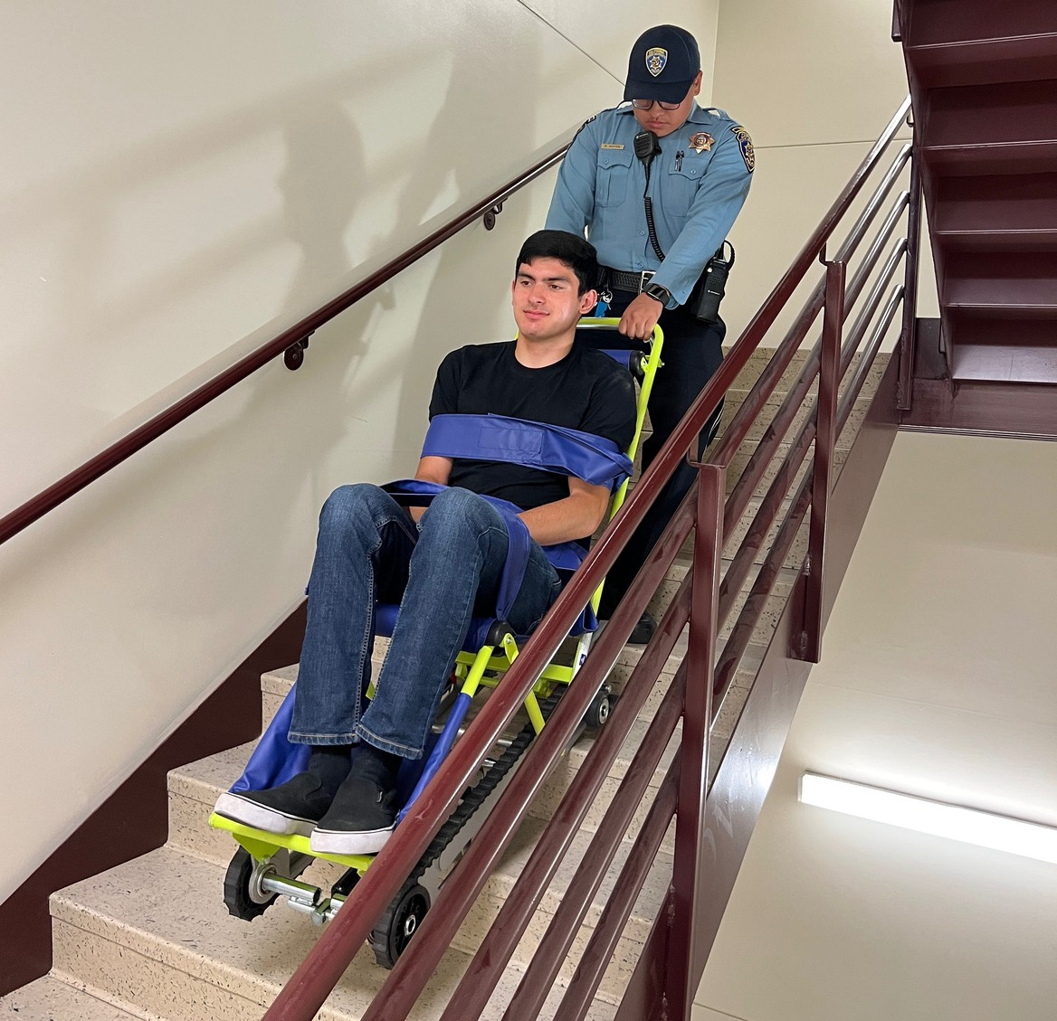
Ask how the person wants to be assisted.
If possible, always evacuate mobility aids (wheelchairs, crutches etc.) with the person. If you are disabled, make arrangements for assistance before an emergency.
Visually Impaired
Describe the nature of the emergency and offer to guide the person through the nearest emergency exit to the Building Assembly Point or safety. Have the person take your arm at the elbow and walk with you – be sure to warn of any obstacles (e. g. stairs, overhanging objects, narrow passageways). When you reach safety, orient the person to their location and ask if further assistance is needed.
Hearing Impaired
Most university buildings are equipped with both high intensity loudspeakers and flashing strobe lights. However, the hard of hearing still may not perceive that there is an emergency. Communicate by writing a note or simple hand gestures.
See a list of SJSU Evacu-Trac Evacuation
Chair Locations available on campus. People with Guide Dogs
Do not pet or offer the dog food without the permission of the owner. When the dog is wearing its harness, it is on duty. If allowing a dog to guide its owner during an emergency is unsafe, ask the owner to remove the dog's harness. Plan for the dog to be evacuated with the owner. In the event you are asked to take the dog while assisting the individual, hold the leash -- not the dog's harness. After exiting the building, ensure that individuals with impaired vision are led to a safe place and that a designated person remains with them until the emergency is over, if possible.
Mobility Impaired (Using Canes, Crutches or Walkers)
Ask the person what assistance he or she prefers. Stair evacuation chairs are located in most multi-story university buildings. Use evacuation chairs only for life threatening emergency situations -- improper use can result in injuries to both those assisting and those being assisted. If an emergency situation is not life threatening, contact the senior building coordinator immediately for assistance. During an emergency, always notify both the building coordinator and emergency responders of

the location of injured and disabled persons.
Mobility Impaired (Wheelchairs)
If a wheelchair cannot be moved with its occupant (e.g. a motorized chair with heavy batteries) move the individual to a safe location where he or she will be as comfortable as possible until mobility is restored. Automobiles make excellent temporary havens. Be sure there is shelter and adequate back support). Never lift a wheelchair by its armrests – always ask the person how to proceed before attempting any move.
Casualties
Cognitive Impairments
People with cognitive impairments may have difficulty recognizing an emergency situation or being motivated to act by untrained rescuers. They may also have difficulty responding to instructions that involve more than a small number of simple actions at one time. When assisting someone with a cognitive impairment, keep in mind:
The person's visual perception of written instructions or signs may be confused or misread/interpreted.
The person's sense of direction may be limited or disoriented, requiring someone to accompany him/her.
Directions or information may need to be broken down into simple steps. Be patient.
Simple signals and/or symbols should be used.
Directions for evacuation may need to be repeated more than once for clarity and understanding.

Do not move injured persons unless there is an immediate threat to their lives -- then only to nearest ground level exit/stairway. Give immediate first aid. Make certain your senior building coordinator/team member knows the location of any disabled or injured persons.

