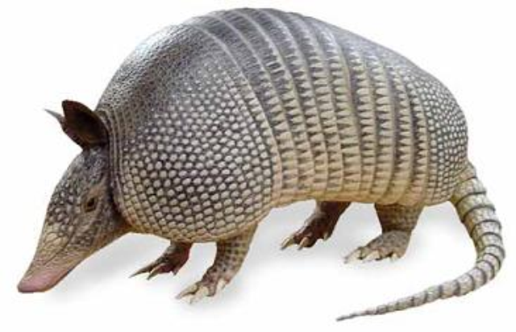
Fall 2011
Zoology 160
Zoogeography

Mondays 5 to 8 p.m. starting August 29

Duncan Hall 549

Zoogeography examines the patterns of animal biodiversity over space and through time. We use data and models from a variety of sources including zoology, ecology, evolutionary biology, paleontology, and geology to examine why, for example, monkeys are so prevalent in Africa but completely absent in Madagascar, or why North America is home to a single species of marsupial while these pouched mammals are more common in South America and especially in Australia. What is responsible for these distributions? Ecology? Geology? Historical accident? Maybe all of the above – and more! This course is an upper division elective for biology majors, but is open to students in other disciplines (geography, geology, anthropology, science education, etc.) who are interested in joining us for this fascinating and often controversial look at animals across time and space.

Instructor: Dr. Elizabeth McGee
For more information, email elizabeth.mcgee@sjsu.edu.

