Comparing versions in word
- Requirements: Papers are in Msword. I have my students submit them to canvas. If in any other format, you will have to take quite a few steps to create a word doc.
- Download both versions (you may have already saved the first version) to separate folders identified as a and b versions (or however you identify for yourself)
- Prepare your comparison settings in Review/track changes/change tracking options
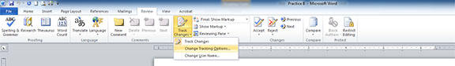

You will see these options—and they will determine what you see in your comparison.
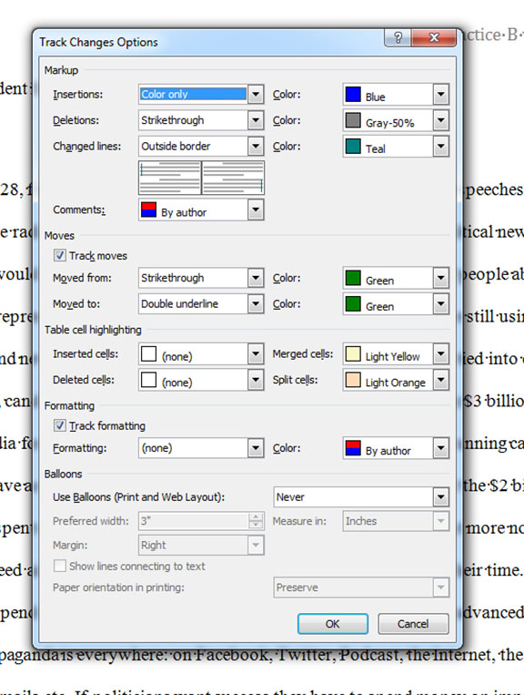

Now go on to comparing first and second versions
- Save each version of the students work so you can discern versions (a or b)
- Open newest version and click on Review
- In review, go to Compare and click on combine documents
- Then choose the appropriate version for each field in the screen that comes up. –more on this below
Screen shots to go with numbers above
- Make sure students identify their files as version a or be:
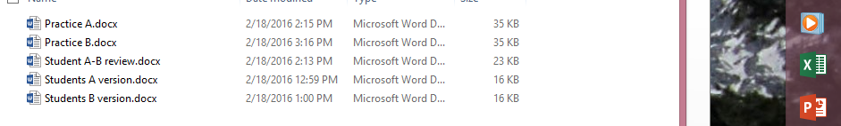
- Open newest version (b in this case) then click on Review
- Go to Compare and Choose combine
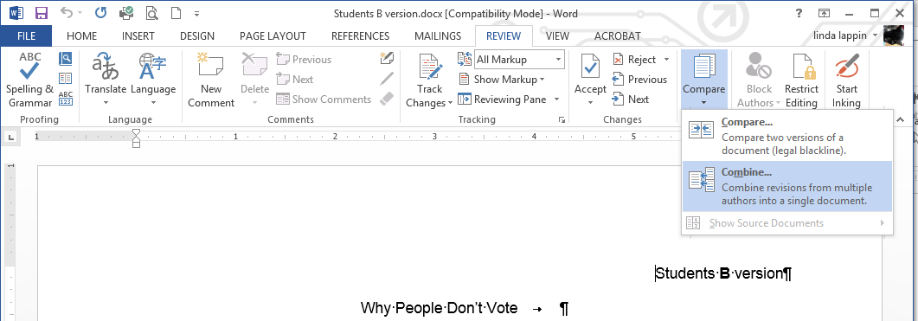
- Then choose the appropriate version for each field in the screen that comes up.
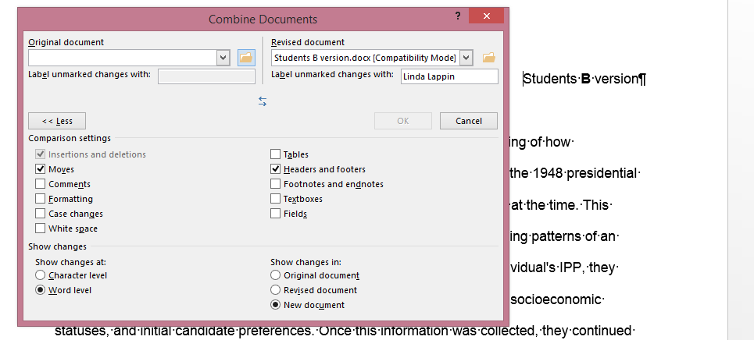
- Because you have the B version open, it will show up in the drop down menu in revised document.
- But the original version is not open, so you will have to click on the file folder and locate it in your student files
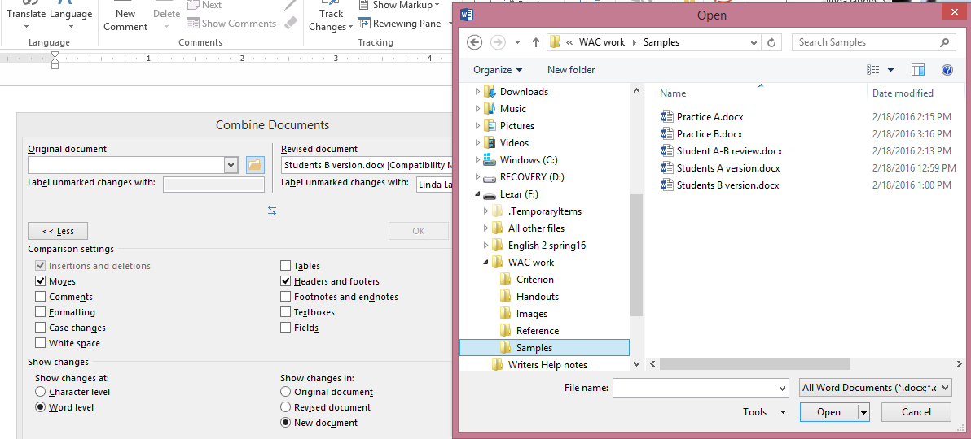
NOTICE that YOU choose what you want to compare—I don’t choose formatting.
- Once both versions are identified, click OK
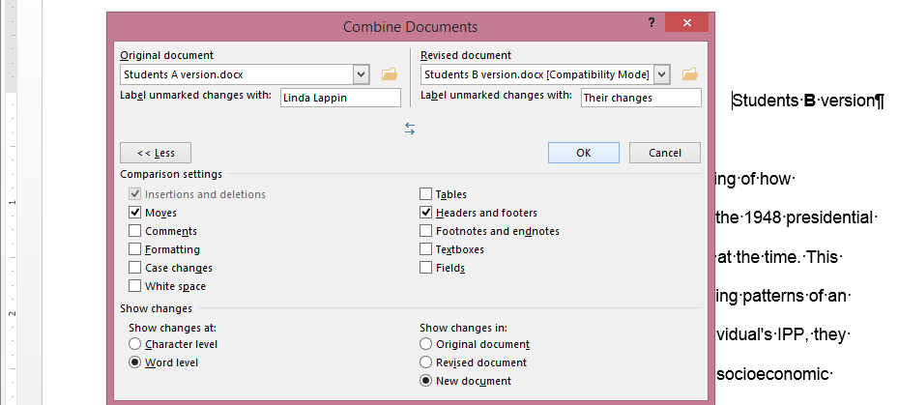
- The following screenshot shows what you should see (if your version of word is the same and mine and you are on a PC):
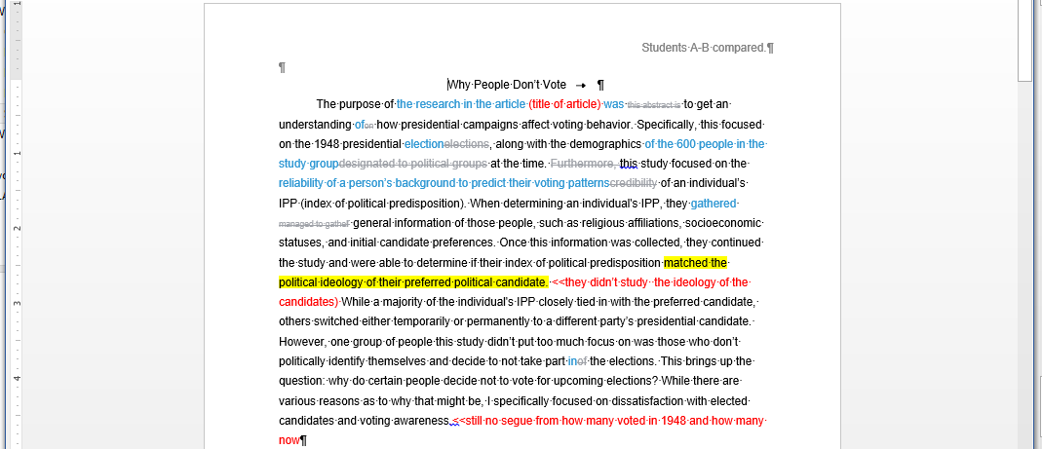
The red notes and yellow highlights are my notes—inserted as I read through the compared documents.
I use highlight indicators: yellow for wording issues, green for clutter, blue for plagiarism, etc.

