Highlights From the English Department Faculty Survey
Fall 2020

1. When we can come back to campus, most of us would like to teach in person or hybrid. Not too many of us are interested in teaching solely online, especially asynchronously.
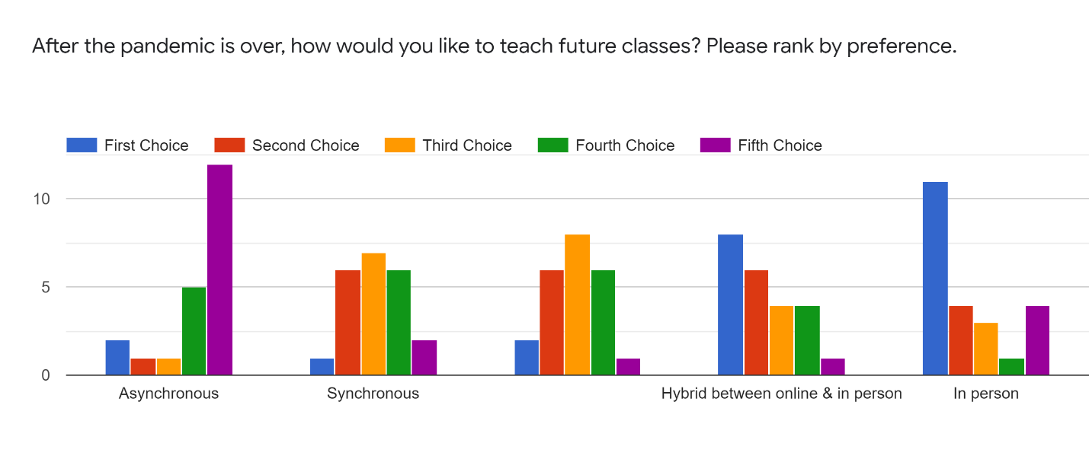

2. If we have to teach online, most of us would like to teach synchronously or a hybrid of synchronous and asynchronous.
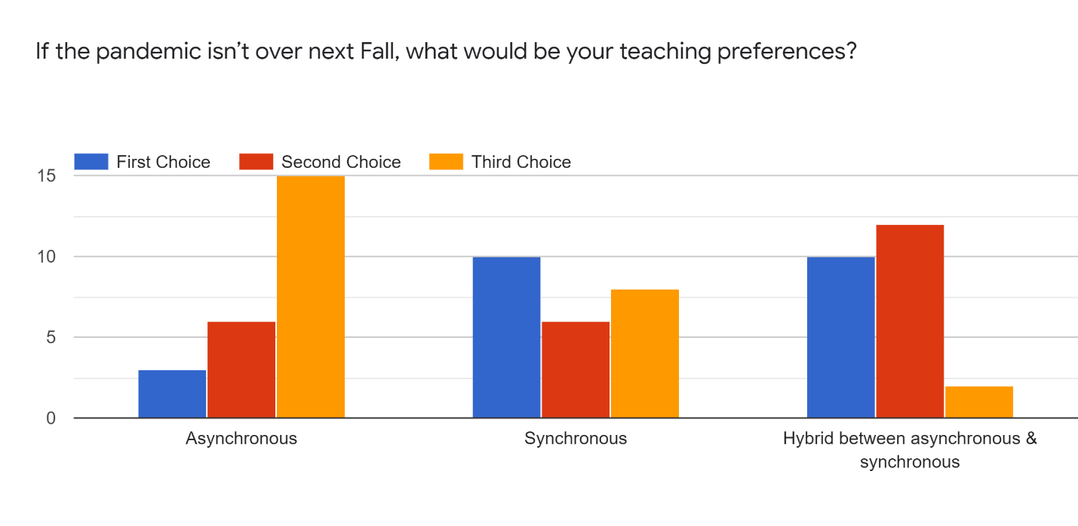

3. We’ve had some real successes teaching online this semester. Some of the cool things we did in our classes:
- Discussion boards
- Chat and breakout features in Zoom
- Zoom
- Sharing screens on Zoom and switching back and forth between full discussion to lecture to sharing Powerpoints
- Using Camtasia to create asynchronous content
- Group assignments
- BADGR BADGES
- Recording Zoom classes
- Collaborative writing assignments

4. Some things that didn’t work too well this semester:
- Breakout rooms did not work well for many of us
- Films
- Students with cameras off
- Organic, free-form discussions were hard
- Transcript feature was only about 80% accurate
- Teaching on Zoom every single class period was tiring for us and our students

5. We did some pretty cool stuff remotely this semester. Highlights include:
- Attending campus events: CLA events, Steinbeck Center events, and Hammer Theater events
- Attending national conferences and events from the comfort of our own homes
- Virtual wine tasting
- Sending students out to find images of medieval manuscripts and the papers, letters and manuscripts of American writers, and seeing just how much information is available online for academic research
- An office hour where I invited students to teach me to play an online community game they were talking about in my sections
- Daybreaker synchronous dance party

6. Staying connected to our students was tough. Staying connected to each other was tough, too. Here are some of the suggestions we have for creating and maintaining a sense of community:
- Maybe a voluntary mentoring program could be useful. Also, a message board or wiki where the information about events and other opportunities to connect stays all in one place could allow us an easy way to remember what is happening
- Maybe a database/session on assignments/strategies/classroom activities that work online
- More social, non-meeting, non-academic interaction (online happy hour, game night, mixer etc.)
- I've really been enjoying the Friday hangouts. Because they are casual, I don't feel (too) guilty about missing them when circumstances prevent it. But it is nice to know it's there to get back to
- Facilitate a department student-faculty open house where they can converse about academics and careers
- I like the weekly meeting that the Dept holds on Friday but it would be good to add one portion of it focused on a teaching topic, either with a presenter or some group work. Maybe also add a drawing for a Starbucks card or some SJSU swag

7. We have some other suggestions and comments, too:
- As we, students and faculty, are all paying for our own internet with high bandwidth and not getting paid any more to be responsible to host and hold our own classroom environments off campus (online), it might be beneficial for the university to support its community members' internet funds. I know many students have been limited by the ability of their internet connections rather than their curiosity
- I'm giving 150% to my students and receiving very little support. An individual e-mail asking about my classes or my stress levels would have been nice

