Pagination for the dissertation
Section 1: No page numbers (pages counted but number is suppressed) – Pages until Acknowledgments or table of contents
Section 2: Lower case roman numerals – Pages from Acknowledgments or table of contents if acknowledgments not used until the introduction chapter.
Section 3: Arabic numerals

Step 1:

Go the last page in section 1 (abstract page) and choose layout Breaksnext page

do the same with the last page on section 2 (list of figures or list of abbreviations)

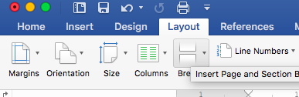

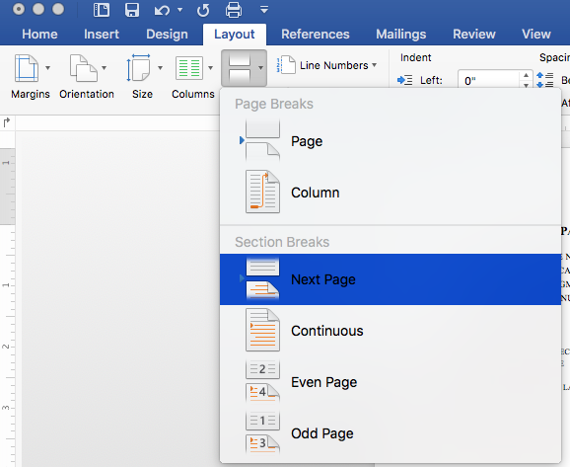
STEP 2:

go to the first page on section 3 – introduction

Click on the footer. On the header and footer ribbon tab that appears on the menu, link to previous will be highlighted, click on it to un-link. Do the same for the header in that page.
Repeat step 2 for the last page on section 2 (with roman numerals).

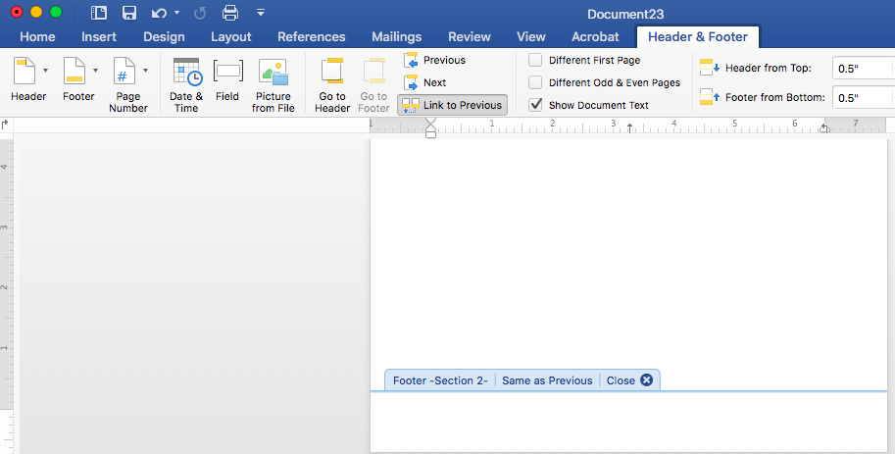

Click on footer

STEP 3:

Go to the first page that has the roman number pagination.

Click on Insert Page NumberPage Number

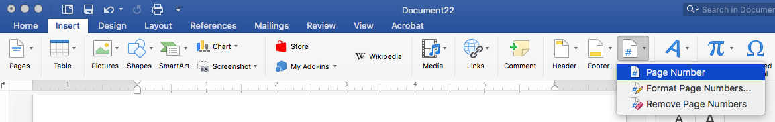

Choose center alignment and click on the format button at the bottom
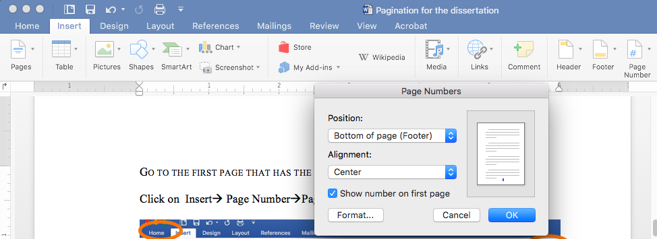

in the format window, choose lower case roman numerals for number format and in the page numbering box choose start at and enter the number you would like to begin the numbering at (it’s usually five)

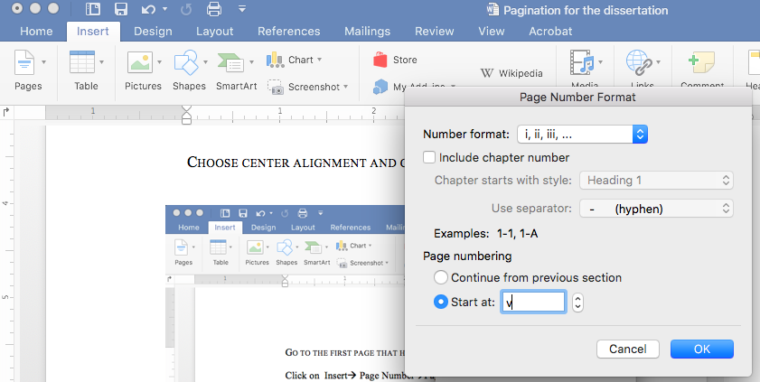

Repeat step 3 for the pages starting with Arabic numerals. in the format window, choose arabic numerals for number format and in the page numbering box choose start at and enter 1.
